### STAKEHOLDER

# ACKNOWLEDGEMENT

We extend our heartfelt gratitude to God for the strength and guidance throughout this journey and everyone, who contributed to the success of "Trash Hunter: Submarine Edition" and the associated gaming report. Your dedication and teamwork were instrumental in shaping both the game and the analysis, creating a collaborative project.

We convey our deepest love and appreciation to our parents for their endless support and encouragement.

Special thanks to our team members for their unique contributions and commitment. Your collaborative spirit enriched the gaming experience and ensured the project's success.

We express our deep appreciation to our mentor, Mr. Riyad Dhuny, for invaluable guidance throughout the journey.

To our friends and family, thank you for your unwavering support and encouragement. Your contributions have made "Trash Hunter: Submarine Edition" a success.  
  
Sincerely,

Jeetoo Stuart

Hurjoon Deepvesh

Manikon Fabrice

Jankoo Moodita

Jeetun Kheertik

Table of Contents

STAKEHOLDER 1

ACKNOWLEDGEMENT 2

THE BEGINNING 6

COMING UP WITH IDEAS 6

IDEAS 6

ABOUT OUR GAME 8

SUSTAINABLE DEVELOPMENT GOAL 8

GAMEPLAY 8

GAME PLOT 8

ABOUT THE GAME 8

WHY THIS IDEA? 9

CORE AUDIENCE 9

LEVELS & BACKGROUND 10

Initial level design - Boat 10

Initial level design – Submarine 10

Level 1 11

Level 2 12

Level 3 12

Level 4 13

Level 5 13

GAME PLOT 14

GAME ASSIGNMENT 14

BEHAVIORS 15

GAME CHARACTERS 15

Submarine 15

Boat 16

Claw 17

Trash 17

Fish 19

Bubbles 21

ENVIRONMENTAL OBJECTS 22

Treasure Boxes 22

Seaweeds 23

Corals 23

GAME OBJECTS 24

Minimap 24

Radar 24

GUI 25

Trash Score 25

Progress Bar 26

OBSTACLES 26

Stones & Corals 26

SOUND 27

Crane sound 28

Sonar sound 28

Background 28

Explosion 28

Underwater sound 28

Whale SFX 28

Waves and Seagull 28

Bubble SFX 28

Big engine start & Run off 28

Motor Boat Sound 28

The Epic Hero 28

GAME FEATURES 29

Admob 29

Process of Admob 29

Single Sign On 31

GAME CONTROLS 31

BUTTONS 33

Gameplay Buttons 33

SCREENS 34

Start Screen 34

Credit Screen 35

MOD Screen 36

Settings Screen 36

Select Level Screen 37

MOBILE UI 38

Responsive Design 38

Touch Friendly Controls 38

Buttons in the Mobile Version Game 38

Game Mobile Interface 39

# THE BEGINNING

## COMING UP WITH IDEAS

For this project, our focus was on the area of Sustainable Development, leveraging the educational aspect of gaming to raise awareness and educate the players on the different global challenges that exist.

### IDEAS

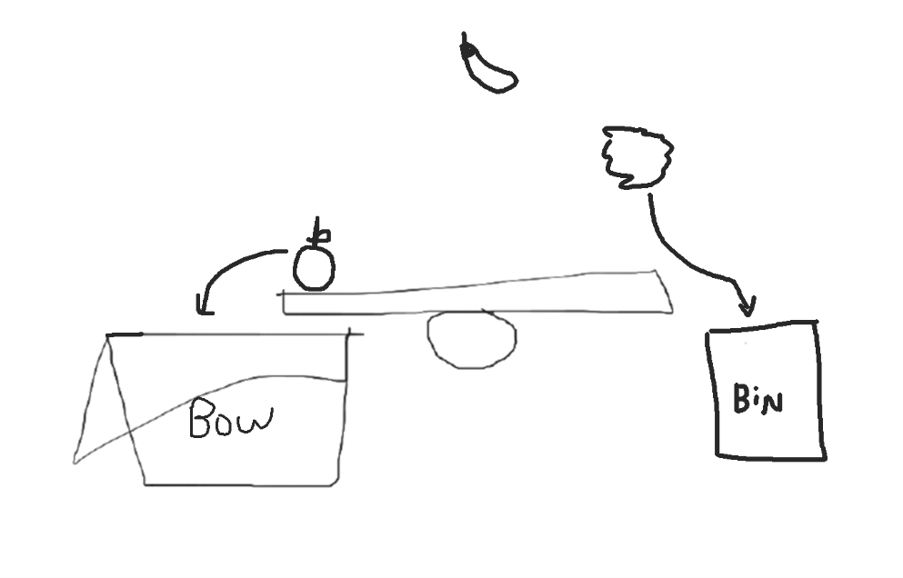Our first idea was based on gender equality and partly on recycling. It was about a cooking game, where the player could have either a male or female character. The player was given different food recipes to work with and had to filter the food or vegetables from the trash. The food stuff goes into a bowl or plate while the trash is disposed into different recycle bins according to their materials by using a seesaw with physics for separation. Furthermore, the players would have the ability to cook food by making use of the ambient light sensor on the device to regulate the cooking fire. That is the strong light will cook faster, however, the food might get burned. On the other hand, low light will take more time to cook. We wanted to implement that part to make the game more challenging and not too mundane.

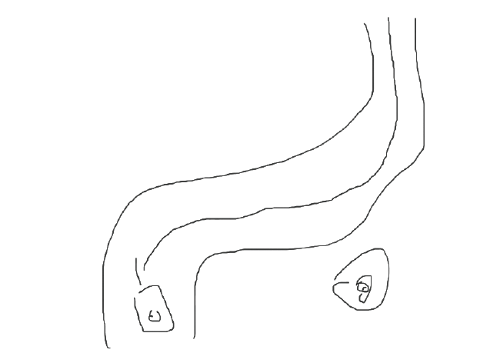Our second idea was based on reducing air pollution caused by fuel driven vehicles. The players would have an electric car to race against bots on a racing track, with diverse obstacles to make the game entertaining. We were thinking to implement mobile sensor such as accelerometer to control the car.  
  
  
  
  
  
And finally for our third idea, we thought about marine life and its ecosystem. It is estimated about 14 tons of wastes produced by human end up in the ocean yearly. The player will be commanding a submarine with a clamp navigating through mazes and avoiding obstacles, to collect trash using a claw. We thought to create an infinite level the main objective would be to collect all the trash before a timer runs out and will be rewarded with additional time when collecting trash.

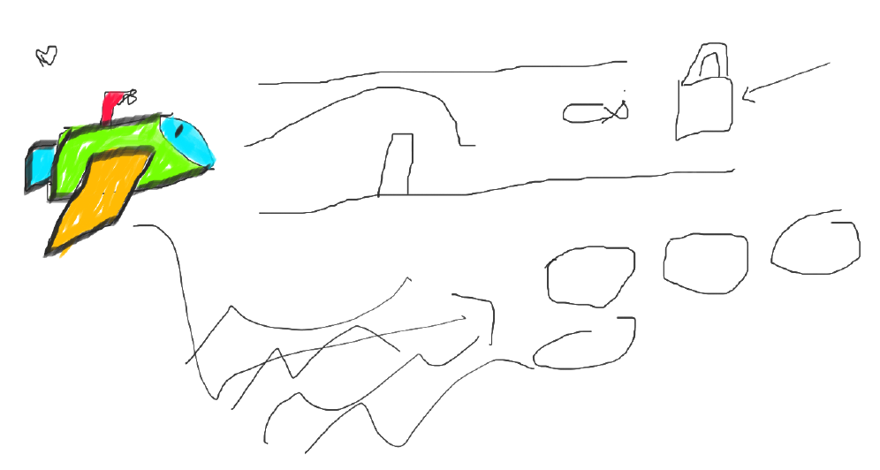

# ABOUT OUR GAME

## SUSTAINABLE DEVELOPMENT GOAL

My team and I had to choose the most impactful out of the three ideas, we decided to go with the submarine one. Marine pollution resulted in a lot of marine life death as the animal either consumed the plastics or got entangled into debris. Additionally, humans being the driving factor of so many deaths are also affected, as consuming seafoods in polluted water is hazardous to human health. Hence, our objective is to use the power of gaming to teach players about the devastating impact pollution has on marine life and to inspire them to take action to protect the ocean and its beautiful ecosystem. In Trash Hunter, you are a submarine Commander willing to contribute to the fight against sea pollution. Into the depths, where silence speaks louder than words!

## GAMEPLAY

Trash Hunter: Submarine Edition is an immersive gaming experience crafted to elevate awareness of ocean pollution and instill sustainable behavior in players. The game unfolds with Abyssal Ranger (The Submarine) as the central character, leading a Trash Hunt. As the submarine navigates through polluted underwater landscapes, it will discover the consequences of neglect and the importance of responsible waste management, recycling, and ocean conservation.

After the players eject the submarine from the boat, they be able to control the submarine and dive into the deep blue sea, navigating through underwater landscapes to capture and remove debris using a claw. As they collect trash, players must return to the boat for an additional time boost otherwise the timer runs out and players will fail the mission. With each successful retrieval, players will gain time boost and the collected trash can later be used for upgrades to improve the boat, claw, and submarine speed. Together, we can save the ocean and protect its delicate ecosystem for generations to come.

## GAME PLOT

In the not-so-distant future, the world's oceans are drowning in pollution, and marine life is on the brink of extinction. Governments and environmental organizations have come together to form the Oceanic Cleanup Initiative, deploying advanced submarines equipped with cutting-edge technology to combat the rising tide of trash. As an elite member of the Trash Hunter squadron, you are tasked with piloting the most advanced submarine, the "Abyssal Ranger," to explore the darkest depths of the ocean and clean up the mess humanity has left behind.

## ABOUT THE GAME

"Trash Hunter: Submarine Edition" combines immersive gameplay with environmental education. As Submarine, players navigate ocean depths, collecting trash and overcoming obstacles. The game seamlessly integrates garbage collection and recycling themes, using unique in-game currencies to teach players about environmental sustainability. The choices made in the game impact both the storyline and the virtual ocean environment, encouraging players to adopt more sustainable behaviors. Ultimately, the game provides an engaging experience that inspires real-world actions for a cleaner, healthier ocean ecosystem.

WHY THIS IDEA?  
Games like "Trash Hunter: Submarine Edition" fall within the serious game’s genre, aiming to influence behavior rather than solely entertain. This form of gameplay serves as a tool for promoting social change, conducting research, facilitating education, and enabling scientific discovery. By emphasizing ecology, such games can delve into the economic, humanitarian, and societal dimensions of environmentalism, offering a holistic exploration of the challenges and opportunities in fostering environmental awareness and sustainability.

CORE AUDIENCE  
"Trash Hunter: Submarine Edition" is designed to capture a broad audience, especially those with an interest in environmental sustainability and awareness. With its focus on garbage management and recycling, paired with interactive and captivating gameplay, "Trash Hunter: Submarine Edition" appeals to both children and adults. The game not only entertains but also serves as an educational tool, imparting valuable lessons about the importance of environmental sustainability and the consequences of pollution.

**Target Audience:**

Age Group: 7 – 15 years old

Gender: Male & Female

# LEVELS & BACKGROUND

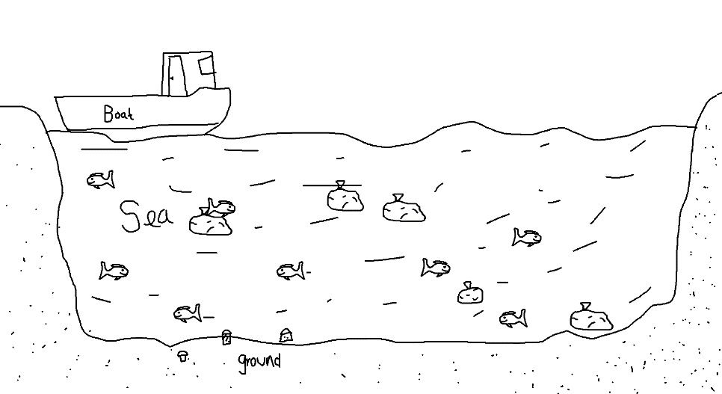Initial level design - Boat  
  
The level starts with a boat floating on the sea, the player will be able move the boat left or right and will be able to eject the submarine anywhere the players want to in the map. While controlling the boat, the player will not be able to interact with trash and the timer will be paused.

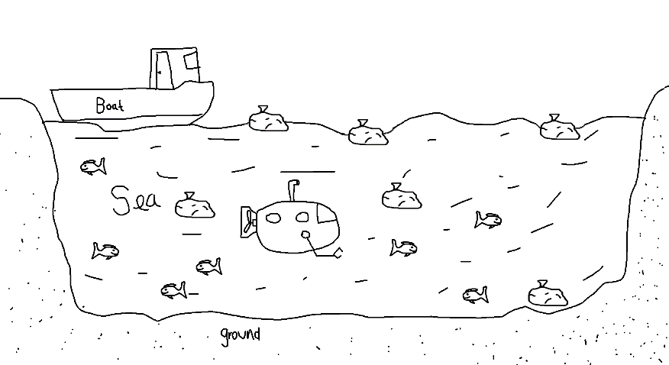  
  
Initial level design – Submarine  
  
Once the player ejects the submarine from the boat, the timer starts. The player’s mission is to collect trash within 5 minutes time limit. The player will have to use the claw to grab the trash and then return to the boat to be rewarded with additional time bonus. Additionally, the total number of trashes collected can be used to purchase modifications to improve boat, submarine, and the submarine’s claw speed.

## Level 1

Level 1 of "Trash Hunter: Submarine Edition" immerses players in a peaceful and scenic beach area. The background is basic yet appealing, with golden beaches running along the shoreline and meeting the serene, azure water. The constant ebb and flow of mild waves creates a relaxing atmosphere, which improves the entire game experience.

The sun casts a warm warmth over the area, and the sky above is painted in gentle blues and subtle oranges, evoking the atmosphere of a serene seaside day. Palm palms wave in the mild breeze, lending a tropical feel to the environment. The basic design of the background allows players to focus on the game's core elements—cleaning up the ocean—in this visually appealing and soothing environment.

As players navigate through the first level, the simple yet aesthetically beautiful beach view serves as a wonderful backdrop, setting the stage for the immersive voyage that lies ahead in "Trash Hunter: Submarine Edition.

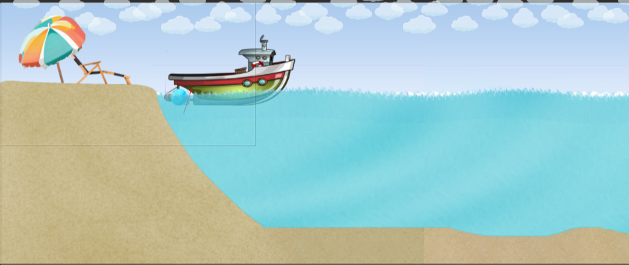

*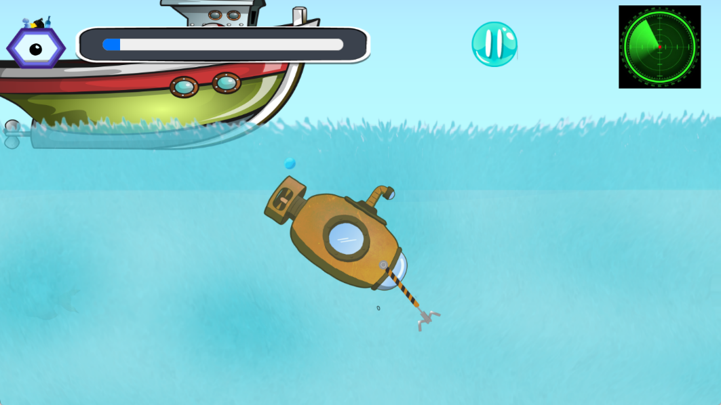Figure 1: Background Level 1*

After the submarine has been ejected, new HUD appears, and the player will be able to take the helm and explore the map.

## Level 2

Level 2 of "Trash Hunter: Submarine Edition" takes players to a radiant and visually magnificent sea environment, complete with flowing seaweeds and strewn stones. The peaceful atmosphere sets the tone for an enjoyable gaming experience.

This level, however, introduces a new dynamic with the addition of a difficult element: fire. As players cruise the bright sea, they must carefully dodge the dangerous flames that threaten the Abyssal Ranger submarine. The addition of this obstacle adds a degree of strategy, pushing players to maneuver carefully and test their talents in the face of adversity.

To equalize the difficulty, Level 2 includes a power-up. Players can find and gather this object to briefly increase the submarine's speed, giving them an advantage when avoiding the dangerous flames. This strategic element adds interest to the gameplay by challenging players and providing opportunities to improve their performance.

In conclusion, Level 2 of "Trash Hunter: Submarine Edition" mixes visual beauty with strategic gameplay, teaching players the delicate ballet of traversing a radiant sea while avoiding damaging fire and utilizing power-ups for a dynamic and fascinating experience.

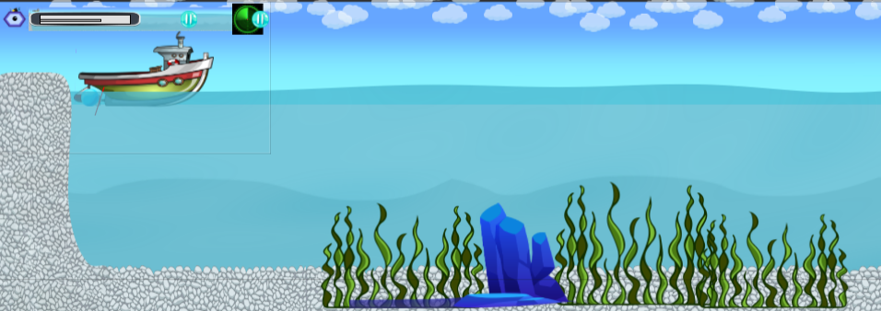

*Figure 2: Background Level 2*

## Level 3

Level 3 in "Trash Hunter: Submarine Edition" features a similar but subtly altered landscape. The placid sea background retains its relaxing attractiveness, now enhanced by the presence of soft, sandy expanses intermingled with scattered boulders. The combination of sand and rocks adds nuanced diversity to the underwater landscape.

As players proceed through Level 3, they will guide the Abyssal Ranger submarine through this balanced environment, where the sandy seabed provides a smoother passage and the rocks present strategic difficulties. The harmonic cohabitation of sand and rocks adds visual interest while also diversifying the gameplay experience, forcing players to adjust their methods accordingly.

With the subtle sway of aquatic plants and the play of light on the ocean floor, Level 3 remains an immersive and delightful backdrop for the ongoing ocean cleanup work. This level demonstrates the game's design adaptability, providing players with a dynamic and exciting experience set against a tranquil and familiar sea backdrop.

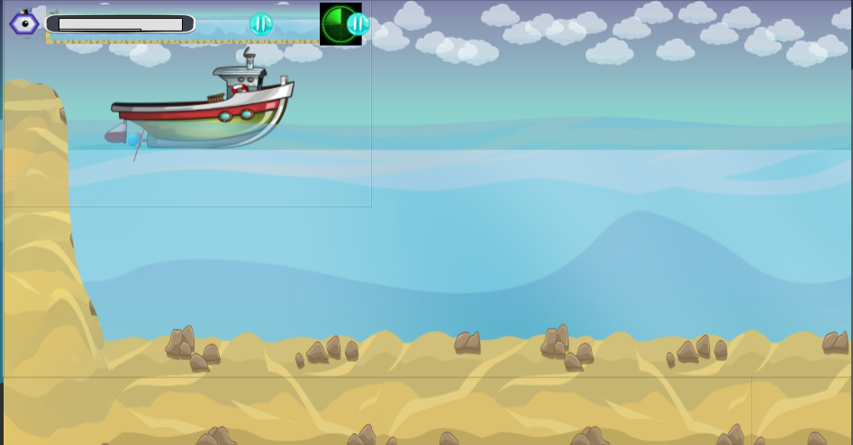

*Figure 3: Background Level 3*

## Level 4

Level 4 of "Trash Hunter: Submarine Edition" transports players to the depths of the ocean, giving a wide and expansive setting characterized by the secrets of the deep. The tranquil blue expanse stretches into the distance, creating an immersive scene that foreshadows a transition into deeper waters.

This level's ocean floor has a sense of depth, with basic yet captivating images that capture the essence of the deep sea. The subtle play of light and shadows lends mystery to the undersea location, resulting in a serene yet awe-inspiring ambiance.

Navigating through Level 4 needs players to face the perils of the deep sea while remaining focused on the primary goal of cleaning up the virtual ocean environment. The shift to the underwater depths adds a new level to the game, providing players with a visually rich and engaging experience in "Trash Hunter: Submarine Edition."

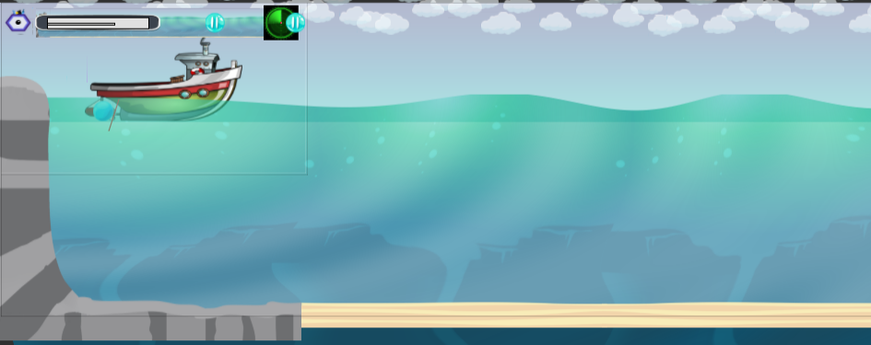

*Figure 4: Background Level 4*

## Level 5

In "Trash Hunter: Submarine Edition," Level 5 features a vivid and lively undersea spectacle. The sea background comes to life with a color explosion, displaying a vast array of marine life as well as vivid seaweeds swaying with the gentle currents. This level provides a visually exciting and dynamic setting, in stark contrast to the simplicity of the previous levels.

The abundance of colorful seaweeds adds a dynamic and whimsical element to the ocean floor, resulting in a vibrant underwater world brimming with life. Schools of fish smoothly flow across the screen, bringing movement and excitement to the beautiful seascape. The use of vibrant colors and marine life improves the overall aesthetic appeal, providing players with a visually stimulating experience as they continue their task of cleaning up the ocean.

Level 5 concludes the gaming experience in "Trash Hunter: Submarine Edition," presenting players with a stunning and satisfying visual backdrop as they navigate through this vivid and dynamic underwater area.

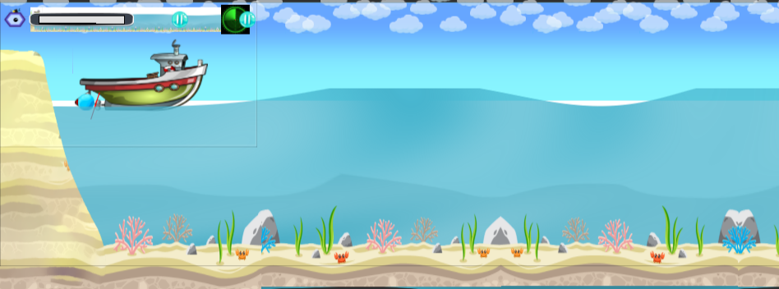

*Figure 5: Background Level 5*

# GAME PLOT

In the immersive adventure "Trash Hunter: Submarine Edition," players take on the role of brave underwater explorers on a mission to rid the seas of rubbish. Armed with a cutting-edge submarine, players descend into the ocean's depths, navigating difficult underwater terrains to catch and destroy garbage. Through this interactive trip, players learn about the devastating effects of pollution on marine life, highlighting the crucial need of ocean conservation.

**Game Genre:** Physics Game

**Theme:** Pollution & Recycling

**Title:** Trash Hunter – Submarine Hunter

**Choice of Background:** We tried to portrait every aspect of the ocean, the radiant beach, marine life and the polluted ocean.

**Game Obstacles:** Stones

**Main Character:** The submarine can collect a total of 40 trash and put it on a boat.

**Game Platform:** Mobile & Web

# GAME ASSIGNMENT

Each team member brought their distinct skills and knowledge to "Trash Hunter: Submarine Edition," resulting in a cohesive and exciting gaming experience.

**Kheertik:** Led the implementation of randomly spawning items, which added a sense of unpredictability to the game. In addition, emphasis was placed on animating fish to improve the underwater environment. Kheertik performed an important role in creating Level 1, which laid the groundwork for the player's quest.

**Deepvesh:** led the submarine's modification, providing unique elements to improve gameplay. I worked on backend functionality to ensure that the game's interactions were flawless. I also took control of Level 4, which added to the variety of play scenarios.

**Stuart:** Used knowledge to improve submarine movement, making it more responsive and intuitive for gamers. Crafted Level 5 demonstrates innovation in developing a visually appealing and demanding gaming environment.

**Fabrice:** Implemented Single Sign-On feature to streamline the player login process. AdMob has been integrated into the game to enable successful monetization techniques. Fabrice's contributions ensured a mix of user convenience and financial viability.

**Jhanvy:** was in charge of designing the start screen, which served as an intriguing entry point into the game. Contributed to backend functionality, resulting in smooth interactions. Additionally, played an important role in developing Level 2, which introduced obstacles and strategic components to the gameplay.

# BEHAVIORS

* Physics
* Platformer
* Sine
* Solid
* Pin
* Fade
* Line of Side
* Scroll To

# GAME CHARACTERS

## Submarine

The Abyssal Ranger in "Trash Hunter: Submarine Edition" is a well-developed component that complements the game's environmental task. This submarine shows a commitment to advanced technology and sustainability, with a streamlined design, strengthened alloys, and cutting-edge vacuum systems that symbolize strength and dedication.

In contrast to traditional game creation, in which characters are meticulously drawn to fit physical qualities and skills, the Abyssal Ranger is a dynamic asset in the game. Its translucent viewport adds to the immersive experience by giving players a visual link to the aquatic world while also emphasizing the game's environmental awareness.

The Abyssal Ranger, like characters in games, evolves with the player's progress, earning upgrades and boosting capabilities. Incorporating recycling technology into its functioning emphasizes the company's dedication to appropriate environmental practices, making it an important and dynamic aspect in the story and message of "Trash Hunter: Submarine Edition." This component is essential not only for gaming, but also for conveying the overarching message of pollution prevention and ocean protection.

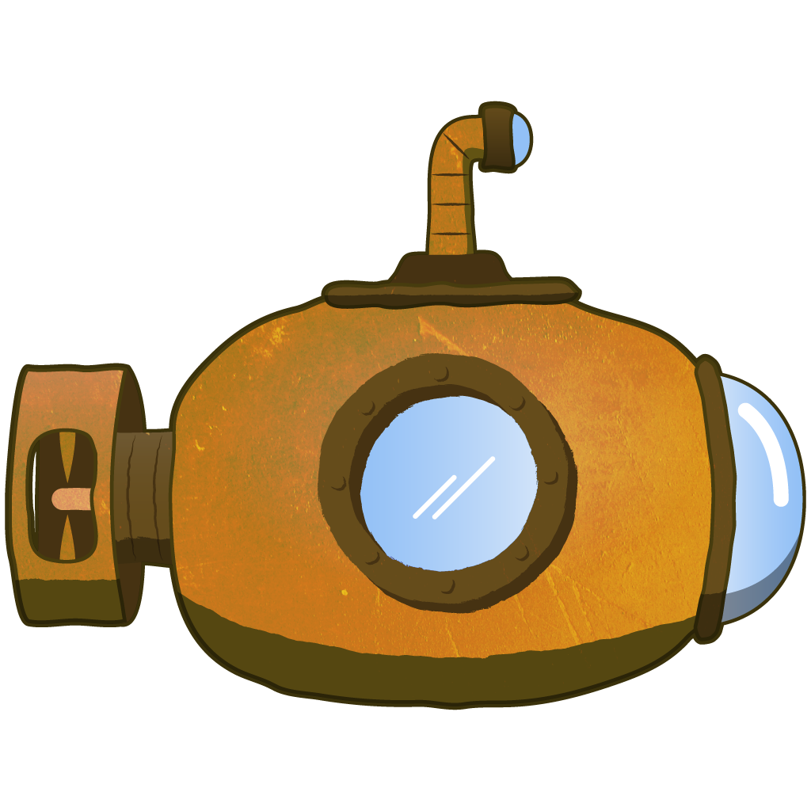

*Figure 6: Submarine*

## Boat

In "Trash Hunter: Submarine Edition," the dedicated support boat is an important part of the ocean cleanup effort. The boat acts as a deployment and recovery hub for the Abyssal Ranger submarine, providing a strategic link between the ocean's surface and the depths below.

Each mission begins with the boat releasing the Abyssal Ranger into the ocean, indicating the start of the cleanup operation. As the submarine carefully collects a significant amount of rubbish, it surfaced and transferred the accumulated debris to the waiting support boat. This symbiotic interplay enables the efficient disposal and recycling of accumulated garbage.



*Figure 7: Boat*

## Claw

In "Trash Hunter: Submarine Edition," the Abyssal Ranger submarine features a specific claw mechanism at the front of its sleek look. This cutting-edge claw is the key equipment for effectively gathering floating debris and rubbish from the ocean depths.

As the submarine travels through dirty waters, players can manipulate the claw to scoop up and secure various forms of debris. The easy controls allow for precision trash targeting and retrieval, stressing the necessity of accuracy and strategic maneuvering during the cleanup process.

This claw mechanism not only improves the gameplay experience by introducing an interactive element, but it also represents the submarine's active environmental protection efforts. This technology underscores the submarine's duty as a loyal guardian, tirelessly striving to clear the ocean of pollution in "Trash Hunter: Submarine Edition."

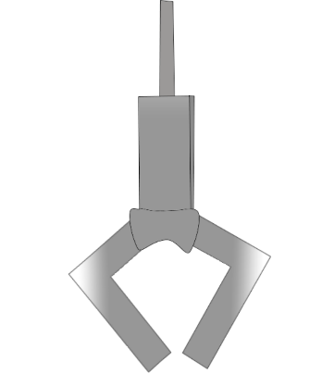

*Figure 8: Claw Animation*

## Trash

In "Trash Hunter: Submarine Edition," the ocean is littered with a wide variety of garbage, from normal litter to hazardous waste. This virtual sea of rubbish, which floats on the surface and spreads across the ocean floor, poses a huge threat to marine life and the delicate balance of the underwater ecosystem.

Players may meet a variety of garbage, including plastic bottles, discarded containers, rusting metals, and other contaminants, each with its own unique features. The visual portrayal of rubbish is both realistic and varied, emphasizing the gravity of the pollution situation throughout the game's plot.

As players maneuver the Abyssal Ranger submarine through dirty seas, their purpose is to collect and eliminate pollutants using the claw mechanism. Successful retrieval helps to the ultimate goal of cleaning the ocean, while also providing as a concrete portrayal of the real-world issues associated with ocean conservation in "Trash Hunter: Submarine Edition."

The trash as a whole was a picture, but we retrieved each item individually.

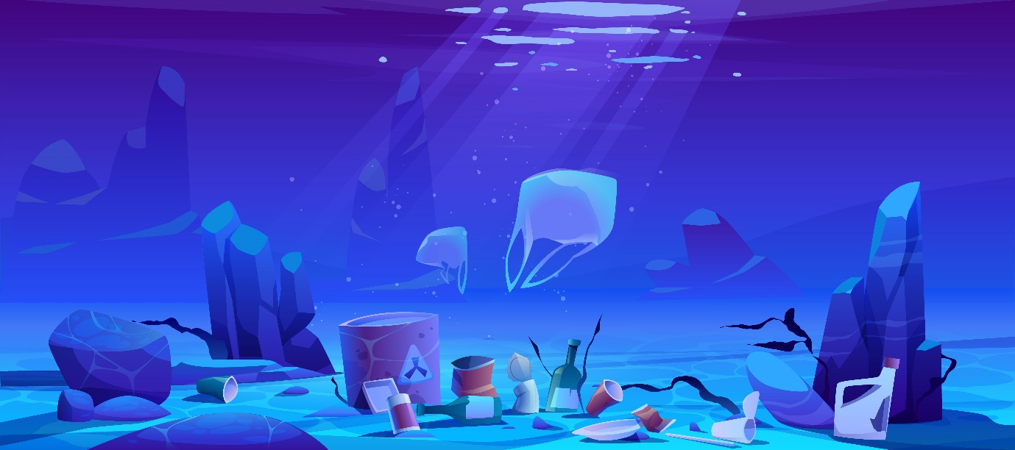

Figure 9: The picture with the all the trash

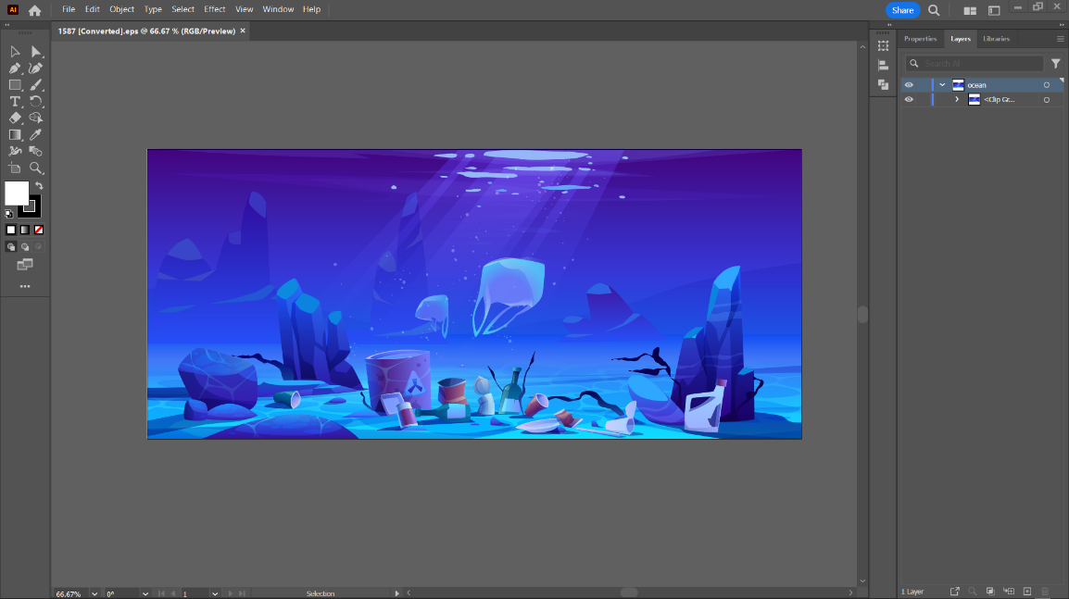

Figure 10: Working to extract the trash

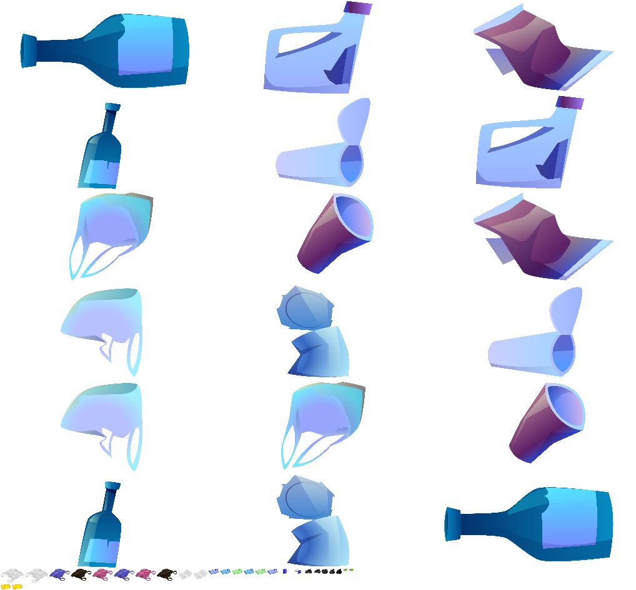

*Figure 11: Trash*

## Fish

In "Trash Hunter: Submarine Edition," the incorporation of diverse fish species adds to the game's visual appeal and realism, creating a more immersive undersea setting. These artificial aquatic residents add to the game's overall attractiveness, bringing the undersea world to life with brilliant colors, sophisticated movements, and a variety of marine behaviors.

As players pilot the Abyssal Ranger submarine through polluted seas, they are treated to a graphically spectacular and dynamic picture of marine life, including schools of tropical fish, gorgeous underwater creatures, and elusive deep-sea inhabitants. The incorporation of these fish not only provides visual value, but also demonstrates the interconnectedness of the ocean ecosystem.

The fish in the game contribute significantly to the virtual environment's realism, reflecting the delicate balance of life beneath the waves. Their existence adds complexity to the story, underlining the importance of protecting the ocean not only for the purpose of cleaning up rubbish, but also for the survival of the various marine life in "Trash Hunter: Submarine Edition."

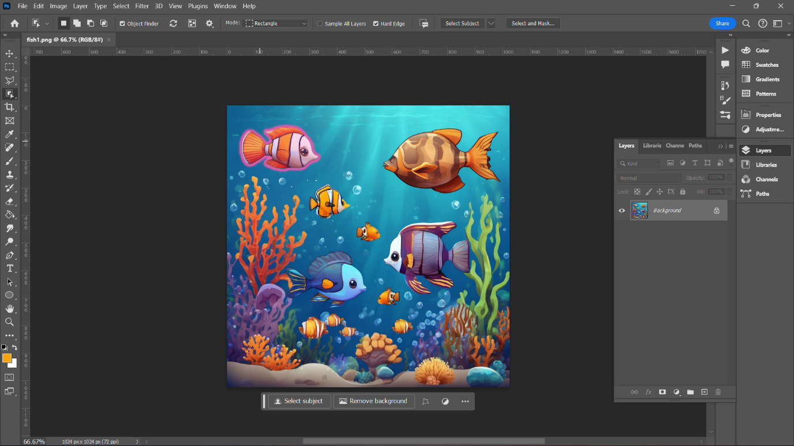

*Figure 12: The Fish in a Picture*

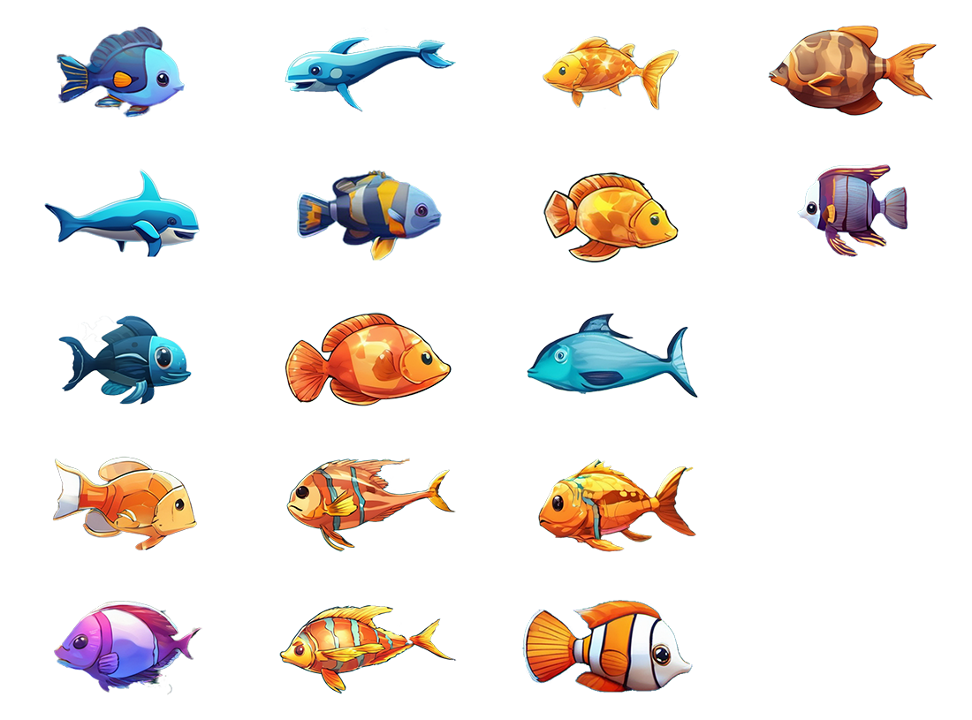

*Figure 13: The Fish Used*

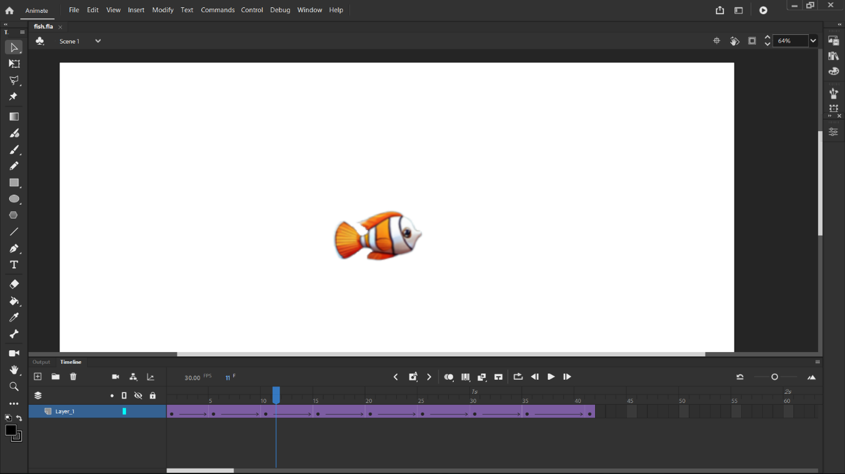

*Figure 14: Putting animation in the Fish*

## Bubbles

In "Trash Hunter: Submarine Edition," the incorporation of moving bubbles provides a lovely and realistic touch to the game, contributing to its overall visual splendor and immersive depiction of the aquatic environment.

As players guide the Abyssal Ranger submarine through the underwater world, the abundance of bubbles provides a visually appealing atmosphere. These moving bubbles not only give a dynamic aspect to the environment, but they also convey a sense of life and movement within the ocean depths.

The bubbles represent the brightness and vigor of the aquatic ecology, in addition to being aesthetically pleasing. This graphic detail, which depicts the natural occurrence of bubbles in the ocean, adds to the game's realism, giving players a more authentic and compelling experience.

In essence, the bubbles in "Trash Hunter: Submarine Edition" play a subtle but important part in making the gaming world more attractive and realistic. They add to the overall aesthetic appeal by immersing players in a visually spectacular portrayal of the ocean and reaffirming the game's commitment to providing an interesting and realistic gaming environment.



*Figure 15: Bubbles Used*

# ENVIRONMENTAL OBJECTS

In the enthralling realm of "Trash Hunter: Submarine Edition," players come across a wide range of ambient objects that serve not only as decorations but also as essential aspects of the undersea landscape. These artifacts offer depth and visual complexity to the water environment, resulting in a more immersive gameplay experience.

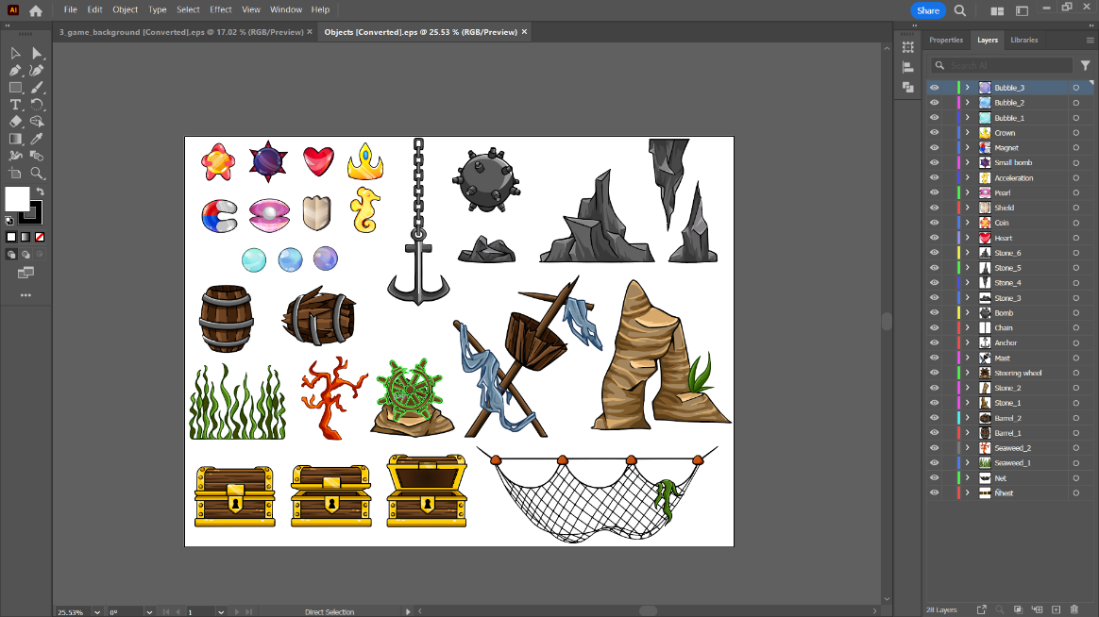

*Figure 16: The Objects Used*

## Treasure Boxes

Each treasure box is carefully placed to evoke a sense of adventure and discovery. As players move across the aquatic environments, the ornamental treasure boxes serve as subtle focal points, tempting them to explore the complexities of the underwater world. Although they do not provide prizes, their inclusion adds an element of aesthetic appeal and interest to the gaming experience.



Figure 17: The Treasure Box Used

## Seaweeds

Seaweeds are graceful and brilliant, and they move with the underwater currents, adding to the ocean floor's visual liveliness. These ornamental components not only enhance the looks, but also create a more realistic and captivating aquatic habitat. Players can navigate among these aquatic plants, adding elegance to their quest.

 

*Figure 18: Seaweeds Used*

## Corals

Corals: Delicate and colorful corals adorn the ocean floor, offering both decorative and environmental purposes. These corals not only enhance the game's visual richness, but they also serve as interactive elements. Players may need to navigate around or through coral formations, adding a strategic element to the gameplay.

 

*Figure 19: Corals*

These environmental artifacts in "Trash Hunter: Submarine Edition" are more than just decorations; they are meticulously constructed features that enhance the gameplay. Whether it's the thrill of discovering treasure chests, the elegant movement of seaweeds, or the strategic navigation around corals, these elements add to the overall immersion and enjoyment of the underwater environment that players explore.

# GAME OBJECTS

## Minimap

In "Trash Hunter: Submarine Edition," the minimap appears as an important navigational aid, dynamically indicating the support boat's movements and strategic maneuvers. This feature not only improves gameplay, but it also gives players with real-time information on the overall mission dynamics.

As the support boat travels through the water, the minimap shows its location, trajectory, and current actions. This visual representation allows players to anticipate the boat's location, which aids strategic decision-making for the Abyssal Ranger submarine. Whether the boat is moving to a new cleanup zone or waiting for the submarine to return with gathered trash, the minimap acts as a useful guide, keeping players informed and involved throughout the gameplay experience.

The inclusion of the minimap adds to the game's user-friendly interface by allowing players to seamlessly coordinate their activities with the movements of the support boat. This addition not only improves practical functionality, but it also emphasizes the sense of teamwork and coordination required for the ocean cleanup mission in "Trash Hunter: Submarine Edition."



*Figure 20: Minimap*

## Radar

In "Trash Hunter: Submarine Edition," the radar system appears as a critical technology that improves the gameplay experience by giving players with a full tracking mechanism for the Abyssal Ranger submarine. This new feature adds to the game's strategic depth and immersion by allowing players to navigate the polluted waters with accuracy and efficiency.

The radar continuously analyzes the submarine's position, motions, and surroundings in real time. It shows important information including local debris, potential hazards, and the overall geography of the ocean floor. This graphic representation provides players with crucial insights that aid in decision-making as they navigate the submarine through various difficulties and cleanup zones.

As the submarine collects rubbish and navigates through various places, the radar becomes an essential tool for strategic planning. It assists players in determining optimal paths, locating certain sorts of debris, and avoiding potential impediments, making the cleanup mission more efficient and enjoyable.

The incorporation of the radar system not only adds realism to the gameplay, but it also emphasizes the role of technology in environmental conservation. By seamlessly integrating radar into the game mechanics, "Trash Hunter: Submarine Edition" provides players with a more immersive and strategic experience as they work to protect the ocean ecology.

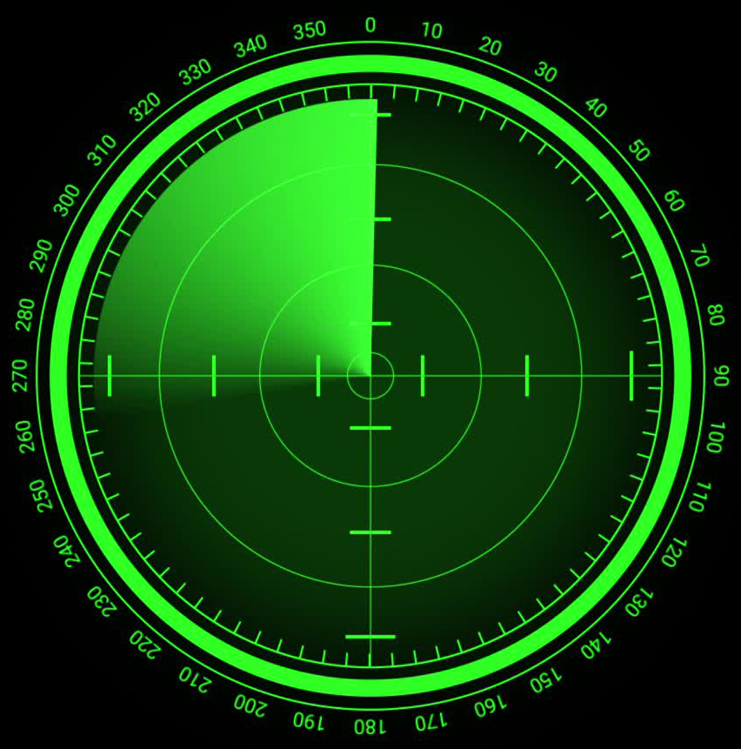

*Figure 21: Radar*

# GUI

## Trash Score

In "Trash Hunter: Submarine Edition," the score bar is a critical component, methodically calculating the total number of trash objects collected by the Abyssal Ranger submarine. This dynamic element not only counts the player's contribution to the cleanup task, but it also turns gameplay into a measurable and gratifying experience.

As players navigate the filthy waters, each correctly recovered piece of garbage adds to the growing total displayed on the scoreboard. This real-time feedback mechanism gives players a vivid and tangible depiction of their efforts to reduce ocean pollution.

The cumulative nature of the score bar adds a degree of difficulty and motivation, motivating players to strive for better totals and mastery in their cleanup efforts. Watching the score rise provides as a visual representation of the player's dedication to environmental conservation in the simulated ocean environment.

In essence, the score meter in "Trash Hunter: Submarine Edition" is more than just a number indicator; it's a dynamic tool that boosts player engagement, giving them a sense of achievement as they actively contribute to making the ocean a cleaner and healthier environment in the game world.

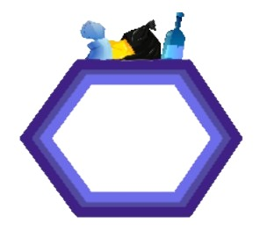

Figure 22: Trash Score

## Progress Bar

In "Trash Hunter: Submarine Edition," the inclusion of a progress bar enhances the gaming experience by giving players with a visual depiction of the game's duration. This dynamic element serves as a guide, providing updates on the general progress and timeframe of the ocean cleanup project.

As the players begin their undersea adventure, the progress meter progressively advances, symbolizing the passage of time throughout the game. This visual cue allows players to measure their pace, estimate the remaining time, and strategically plan their activities to optimize their impact on cleanup efforts.

The progress bar is not simply a temporal indication, but also a technique for maintaining a sense of urgency and excitement during gameplay. As the bar fills, players are encouraged to efficiently cruise the ocean depths, gather rubbish, and complete their objectives before the mission ends.

To summarize, the progress bar in "Trash Hunter: Submarine Edition" is an important feature that improves the whole gaming experience. By giving players a clear sense of time progression, the game becomes more immersive and interesting, allowing players to successfully manage their efforts during the ocean cleanup mission.

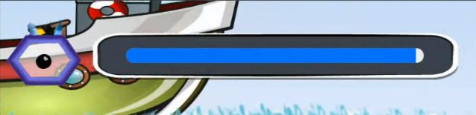

Figure 23: Progress Bar

# OBSTACLES

## Stones & Corals

In "Trash Hunter: Submarine Edition," the undersea environment is not only dense with garbage, but it also poses unique obstacles in the form of stones and corals. These natural components provide another degree of difficulty to the action, forcing players to travel carefully to avoid obstructions.

Stones of varied sizes and location create strategic bottlenecks through which players must successfully navigate the Abyssal Ranger submarine. These obstacles put the player's precision and control to the test, highlighting the importance of strategic thought in order to avoid collisions and travel properly while cleaning up rubbish.

Corals, with their elaborate and often brittle structures, serve as both visually beautiful and demanding challenges. Players must manage these sensitive ecosystems to avoid damage and maintain the game's environmental commitment. This feature not only adds challenge to the game, but it also emphasizes the need of maintaining and protecting maritime habitat.

The addition of stones and corals as barriers enhances the gameplay experience in "Trash Hunter: Submarine Edition." It converts the ocean environment into a dynamic and demanding place in which players must balance effective trash collecting with precise navigation in order to complete their task of cleaning up the virtual underwater world.

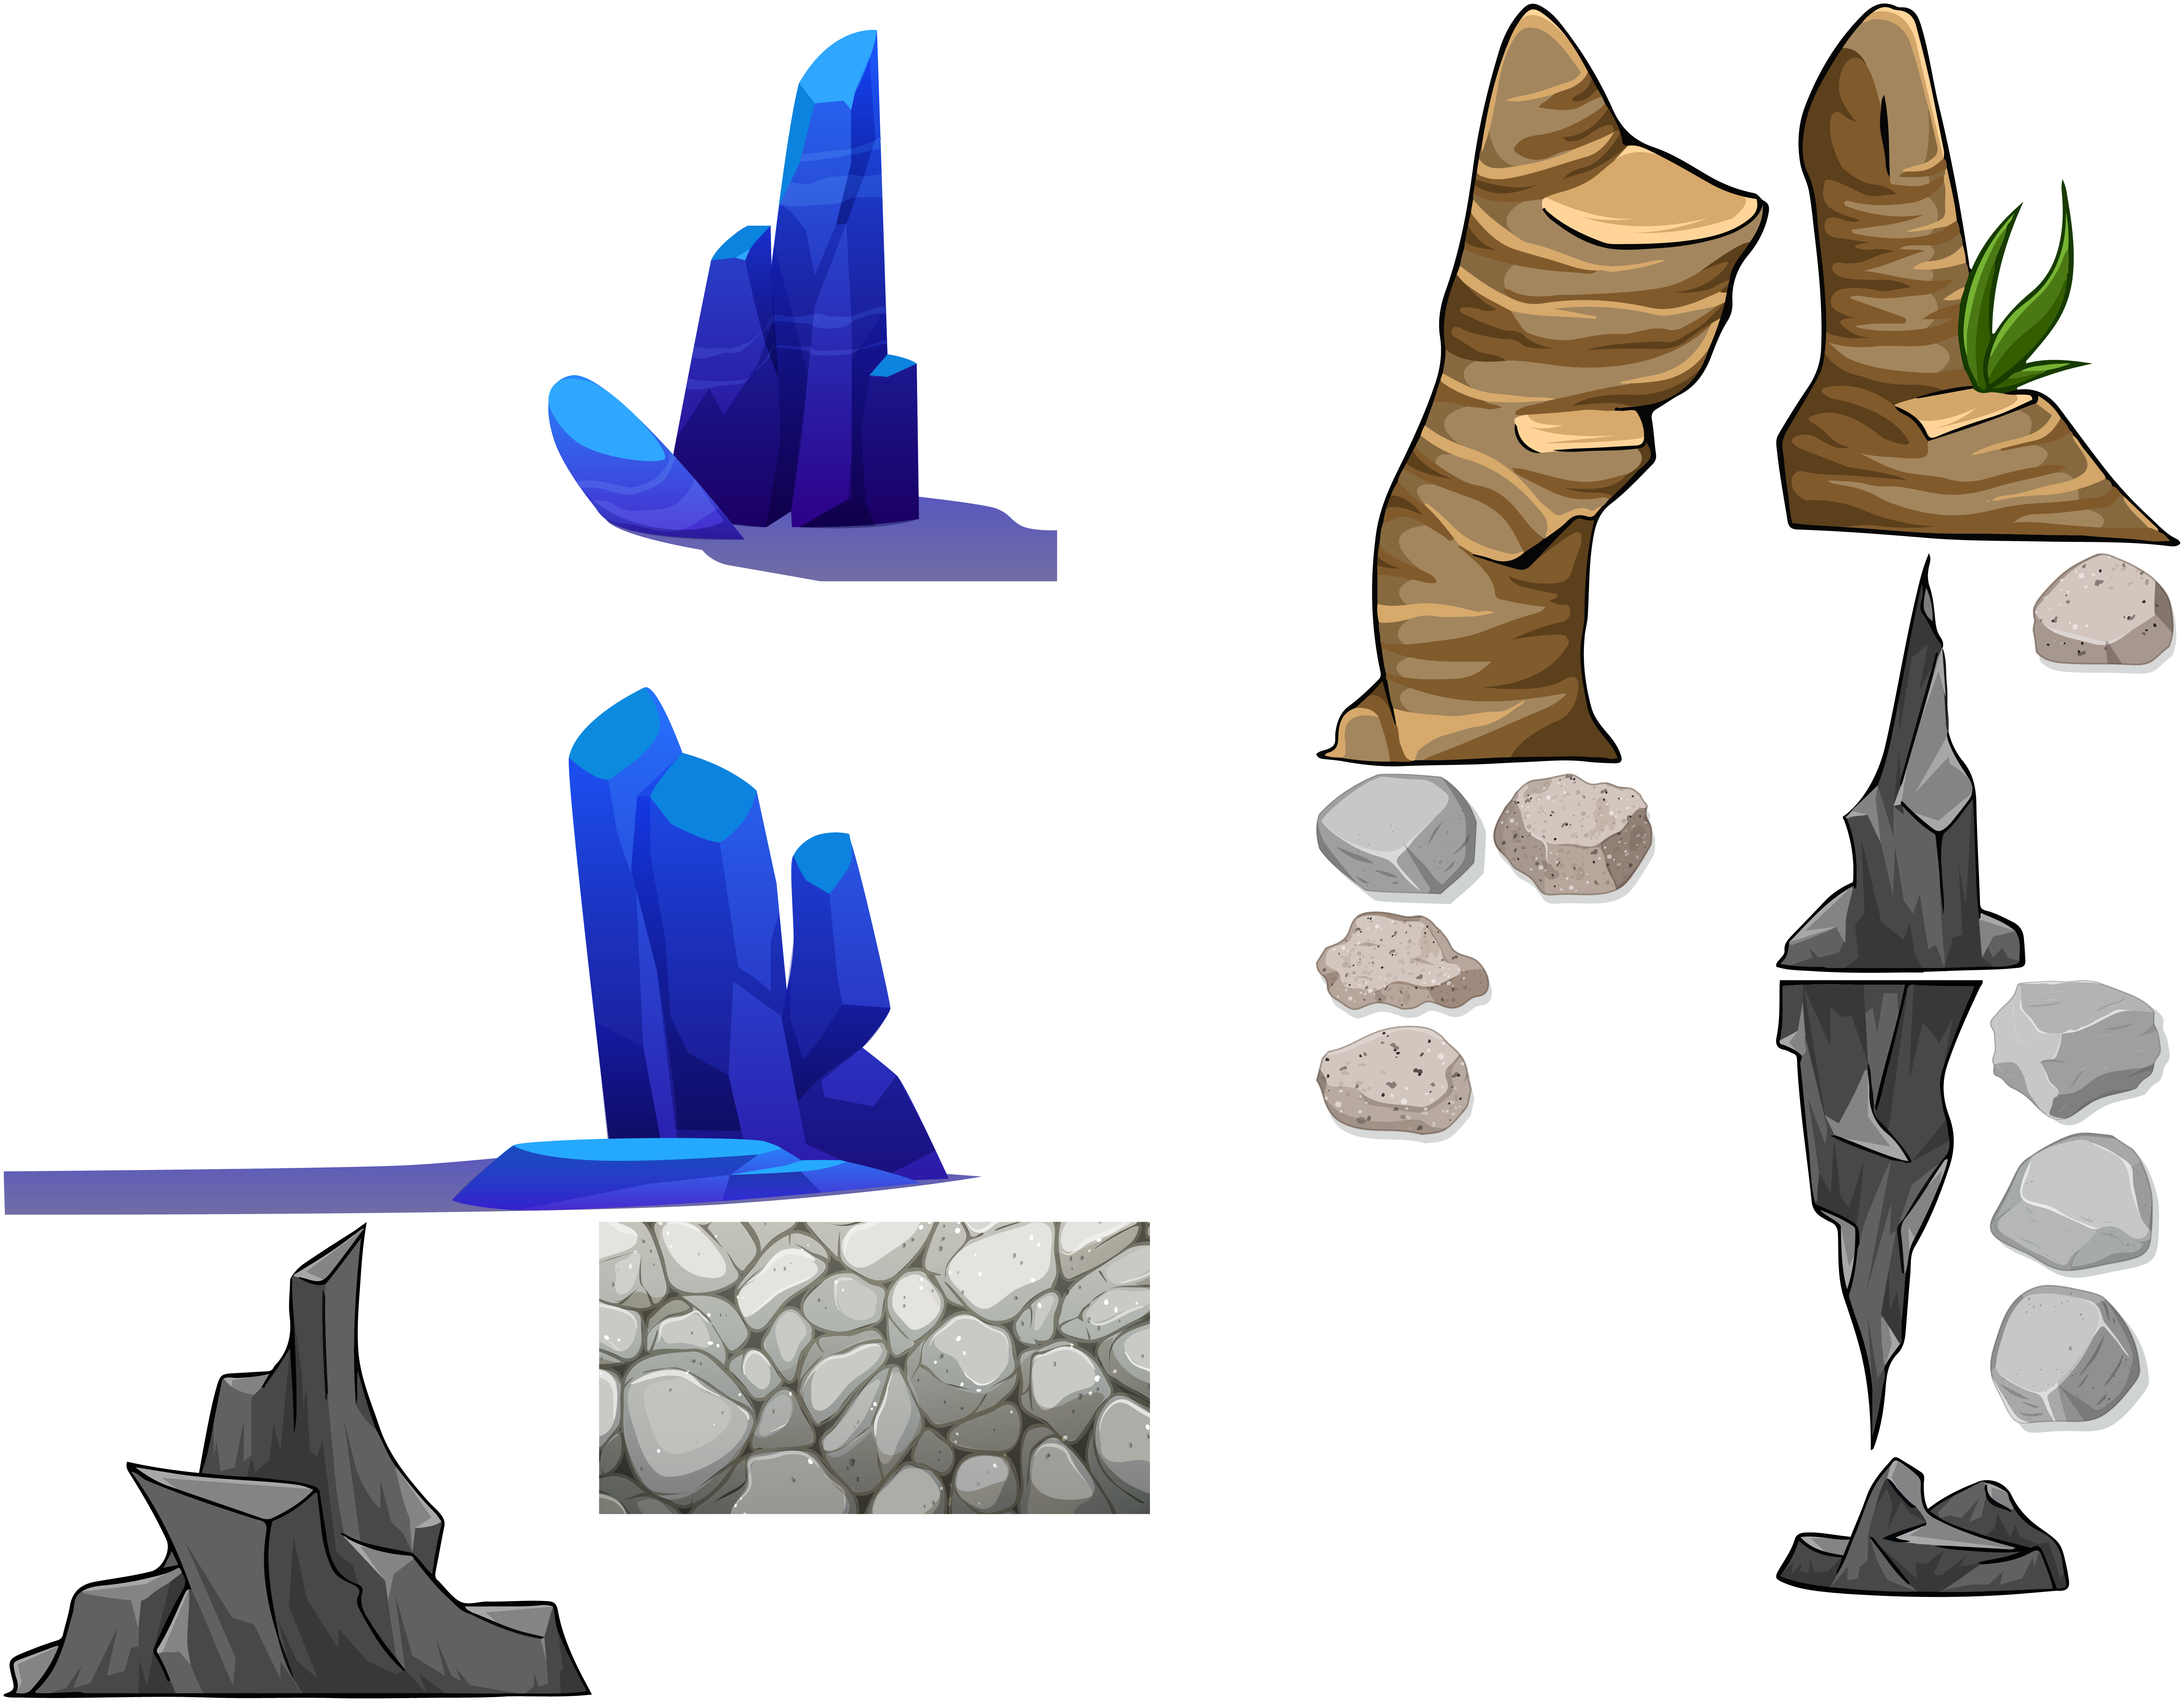

Figure 24: Stones and Corals

# SOUND

The soundscape is vital in providing an immersive and compelling game experience. The carefully designed audio elements contribute to the overall mood, providing depth and realism to the undersea environment.

Please note that permission was obtained from the owner to utilize the following sounds.

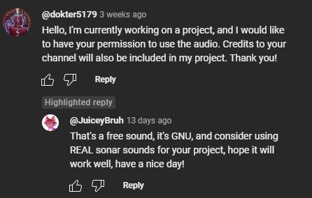

*Figure 25: Permission Proof*

## Crane sound

<https://www.youtube.com/watch?v=_r7rF_Fo92Q>

## Sonar sound

<https://www.youtube.com/watch?v=O1eG1htakEs>

## Background

<https://www.youtube.com/watch?v=2W-SWObqSqM>

## Explosion

<https://www.youtube.com/watch?v=vxgFRE0z2QE>

## Underwater sound

<https://www.youtube.com/watch?v=la_AEFO8m7U>

## Whale SFX

<https://www.youtube.com/watch?v=8rBMdJYkEL0>

## Waves and Seagull

<https://www.youtube.com/watch?v=HKmEWRZNJ3k>

## Bubble SFX

<https://www.youtube.com/watch?v=NALg_oqdg_Y>

## Big engine start & Run off

<https://www.storyblocks.com/audio/search/boat-engine-start-sound>

<https://www.storyblocks.com/audio/stock/big-engine-start-idle-rgcm2so3uwbk0wxow07.html>

## Motor Boat Sound

<https://pixabay.com/sound-effects/motorboatsound-32776/>

## The Epic Hero

<https://www.youtube.com/watch?v=6wMNM0BjJGM>

# GAME FEATURES

## Admob

In "Trash Hunter: Submarine Edition," AdMob integration improves the gaming experience by introducing non-intrusive adverts. AdMob effortlessly integrates advertising at appropriate points throughout the game, delivering a balanced strategy that does not disturb gameplay while also allowing players to engage with relevant material.

This ad monetization method helps to ensure the game's long-term viability by producing income while allowing gamers to play for free. AdMob's inconspicuous nature preserves the immersive quality of the gaming experience, establishing a balance between giving value to players and supporting game development.

Overall, the use of AdMob in "Trash Hunter: Submarine Edition" demonstrates a sensible approach to in-game advertising, which contributes to the game's financial viability while maintaining user enjoyment and engagement.

### Process of Admob

To integrate adverts into the game, first create an AdMob account. Next, create an app on AdMob and configure ad units to incorporate interstitial advertisements. Proceed to the Construct platform and insert the advertising into the game using the "Mobile Advert" object. Include the Android app ID in the item.

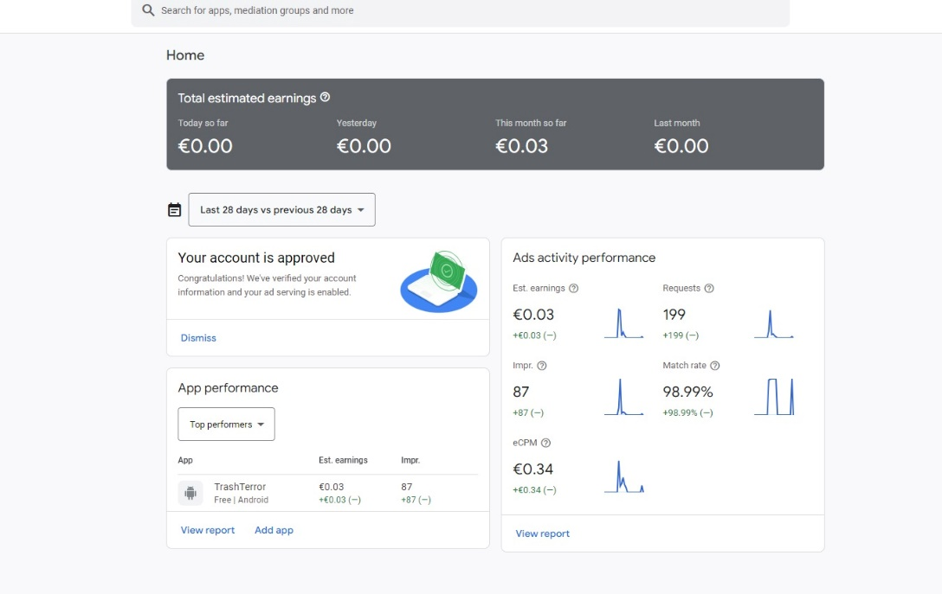

*Figure 26: Statistics Earnings for last 28 days*

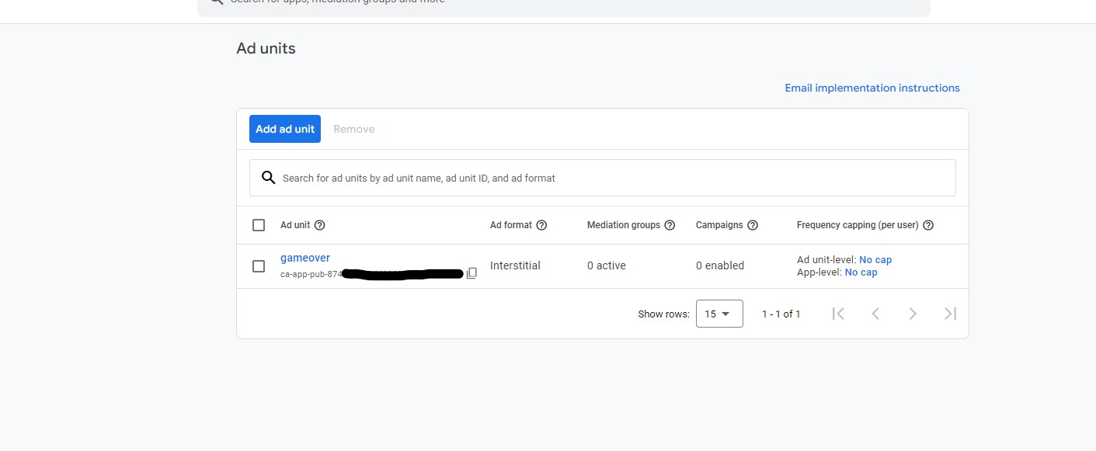

*Figure 27: Types of Ads and Ads ID (Interstitial Ads)*



*Figure 28: Creation and Loading of Advert (Blurred due to Security Reasons)*



*Figure 29: Object added for Advert*

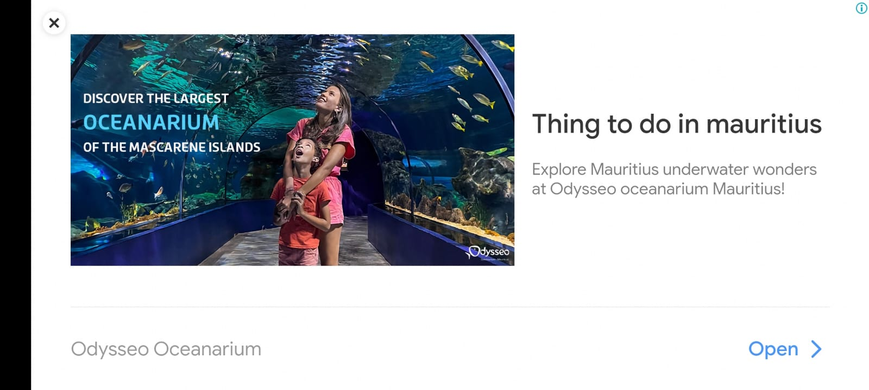

*Figure 30: Final & Working Ad*

## Single Sign On

Single Sign-On (SSO) is implemented in "Trash Hunter: Submarine Edition," which streamlines the player's experience by delivering a seamless and speedy authentication process. SSO allows users to use a single set of credentials to enter the game, eliminating the need for multiple logins.

This convenience simplifies the onboarding process while also increasing player engagement. SSO helps to improve the gaming experience by minimizing friction during the login process. Whether players move devices or return to the game after a break, SSO provides a quick and easy login, increasing accessibility and user happiness.

The addition of Single Sign-On to the game matches with modern user expectations, stressing a user-centric design that stresses efficiency and convenience of use in "Trash Hunter: Submarine Edition."

# GAME CONTROLS

In any game, learning the fundamental controls is critical for players to travel and interact with the virtual world. "Trash Hunter: Submarine Edition" is no exception, with straightforward controls that improve the play experience.

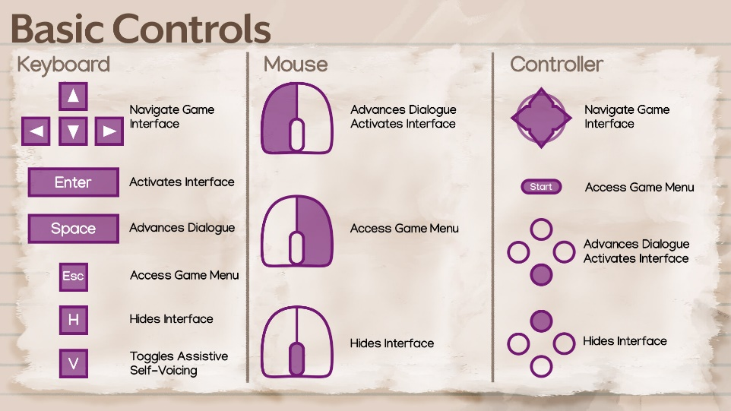

*Figure 31: Basic Controls*

In this undersea adventure, players use simple controls to pilot the Abyssal Ranger submarine and communicate with the support boat. The space bar has two functions: it allows players to remove and enter the submarine from the boat, providing freedom in movement and strategic decision-making.

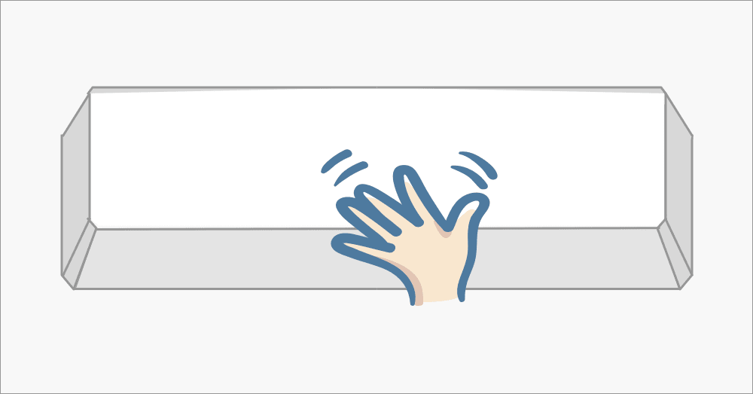

*Figure 32: Space Bar to remove and enter submarine from the boat*

When submerged, the arrow keys become the player's navigation tool, allowing for fine control over the submarine's course. This enables players to navigate the ocean depths with precision, avoiding obstacles and efficiently gathering rubbish.

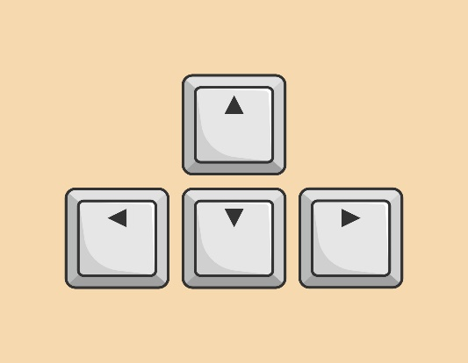

*Figure 33: Arrow Keys for Submarine Directions*

The usage of mouse controls simplifies interaction with the surroundings. The right-click releases collected debris into the support boat, which helped with the ongoing cleanup work. In contrast, the left-click triggers the submarine's claw mechanism, allowing players to skillfully remove debris from the ocean, stressing a hands-on approach to pollution prevention.

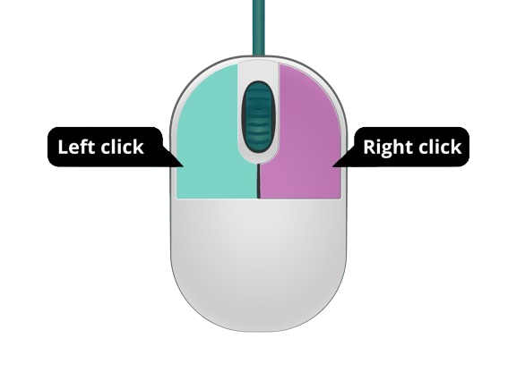

*Figure 34: Right Click collects trash and Left Click triggers Claw Mechanism*

By including these simple controls, "Trash Hunter: Submarine Edition" allows players to focus on the task at hand - cleaning the ocean - without being distracted by intricate commands, making the gameplay accessible and pleasant to players of all skill levels.

# BUTTONS

"Trash Hunter: Submarine Edition" ensures user convenience with essential buttons, including pause for temporary halts, restart for fresh opportunities, settings for customization, and a credit button for acknowledging contributors. These features empower players to control their gaming experience, customize preferences, and explore credits for a comprehensive and user-friendly gameplay session.

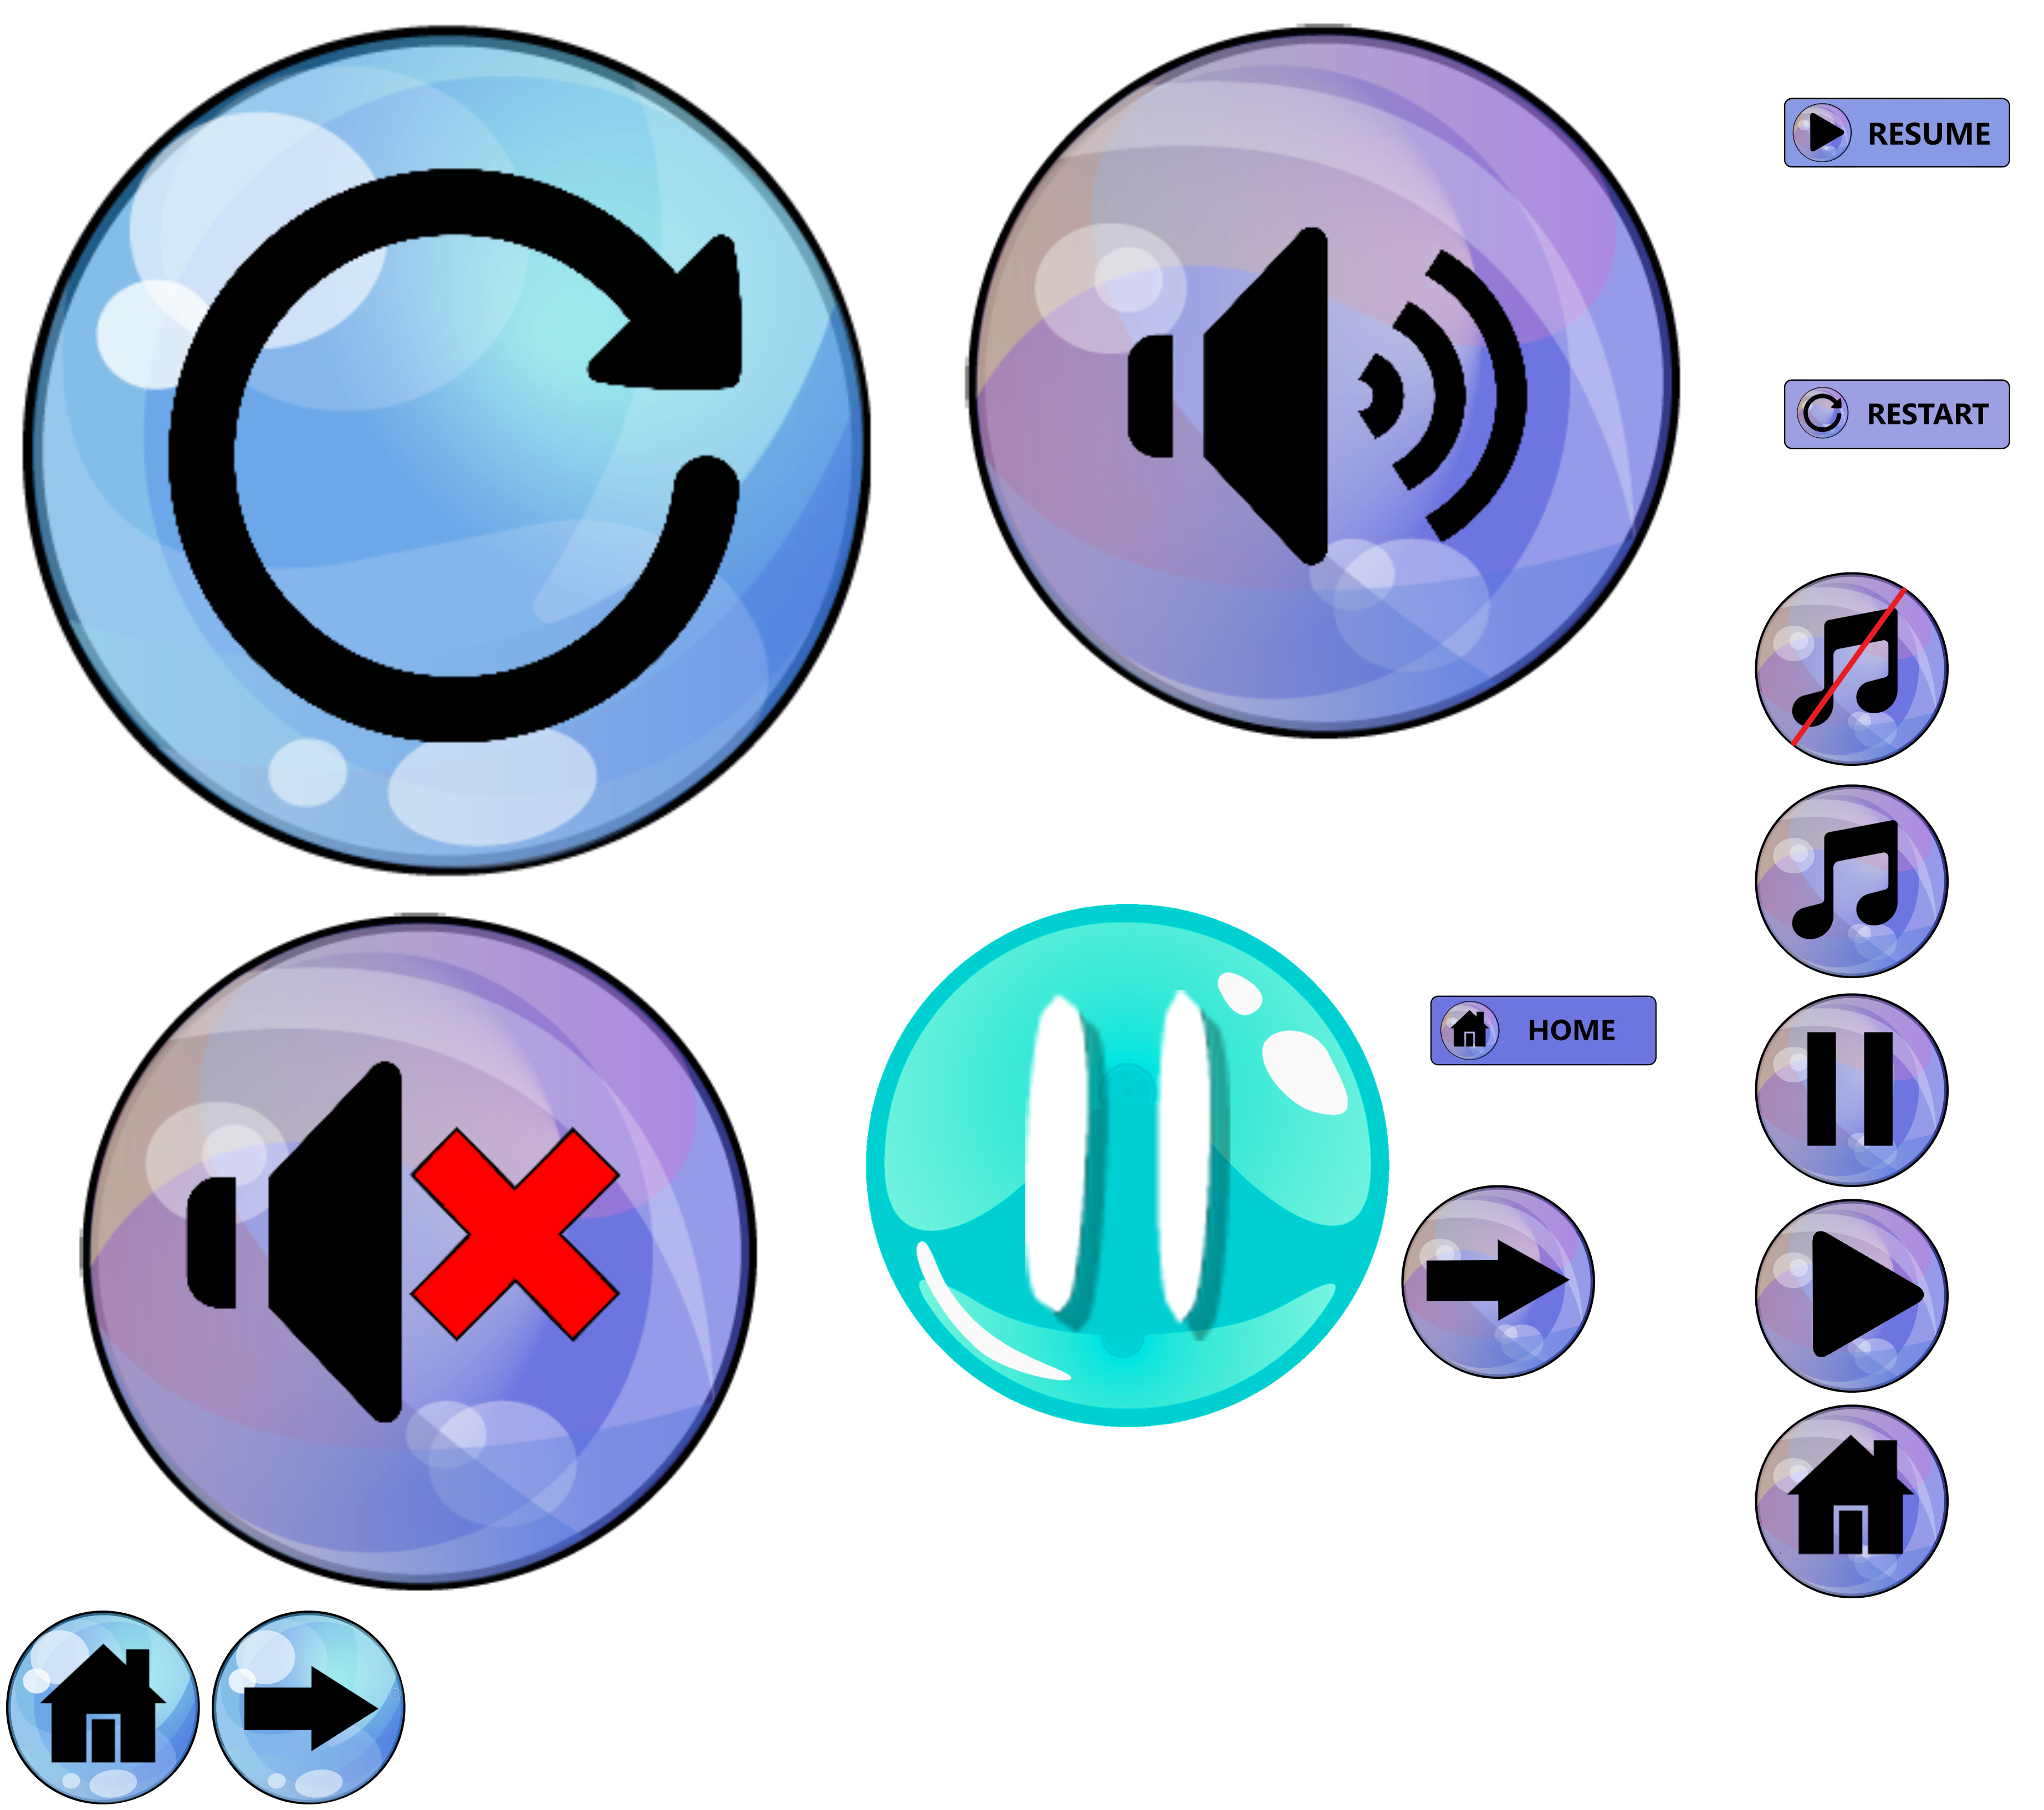

*Figure 35: Game Buttons*

## Gameplay Buttons

"Trash Hunter: Submarine Edition" focuses user-friendly controls by including crucial buttons that improve the entire play experience. These buttons give players easy ways to manage gameplay and navigate across many areas of the game environment:

**Play Button:** The "Play" button invites players to dive into the underwater adventure, initiating the mission to clean up the ocean.

**Credit Button:** The "Credits" button provides recognition to contributors and enhances transparency about the game's development.

**Settings Button:** The "Settings" button allows players to customize their gaming experience, adjusting preferences such as audio, graphics, and controls.

**Back Button:** The “Back” button offers players a convenient way to return to the previous screen or menu, enhancing flexibility and ease of interaction during gameplay.



*Figure 36: Play Button*



*Figure 37: Credit Button*



*Figure 38: Settings Button*



*Figure 39: MOD Button*

# SCREENS

## Start Screen

The start screen of "Trash Hunter: Submarine Edition" is a comprehensive hub built for simple navigation and user engagement. The start screen provides players with a dynamic and easy entrance point into the game, featuring prominent buttons such as "Play," "Credits," and "Settings," as well as a dedicated "MOD" area.

The "Play" button invites users to dive into the undersea adventure and begin the task to clean up the ocean. The "Credits" button acknowledges contributors and increases transparency about the game's development. The "Settings" button allows users to tailor their game experience by altering audio, visuals, and controls.

The presence of a "MOD" section suggests possible modifications or more content, offering adaptability and potential growth to the gameplay. Collectively, these aspects on the start screen not only improve usability, but also show the game's devotion to player agency and a rich, personalized gameplay experience in "Trash Hunter: Submarine Edition."

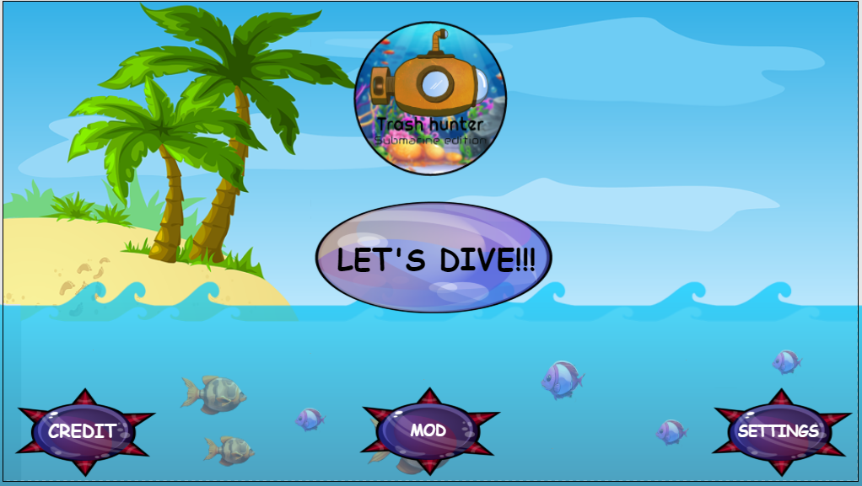

*Figure 40: Start Screen*

## Credit Screen

The credit screen in "Trash Hunter: Submarine Edition" pays respect to the people who used their skills and imagination to bring the game to reality. This section recognizes the developers, designers, artists, and other individuals whose combined efforts helped build the immersive gaming experience.

The credit screen, which is thoughtfully designed, provides insights into the talent behind the scenes, allowing for transparency and acknowledgment. It could include names, roles, and even excerpts about each contributor's involvement in the game's production.

By displaying the credits, "Trash Hunter: Submarine Edition" not only communicates gratitude to the team, but also encourages players to appreciate the collective effort that went into making the game. It personalizes the game experience, generating a sense of connection between players and the creative minds who brought the aquatic world to life on their screens.

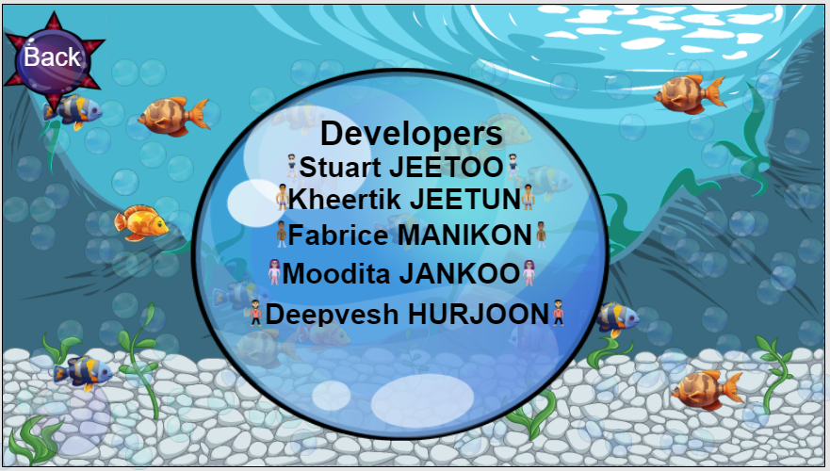

*Figure 41: Credit Screen*

## MOD Screen

The MOD screen in "Trash Hunter: Submarine Edition" is a central location where players can upgrade their submarine, claw, and boat. These modifications include increasing submarine speed for greater maneuverability, boosting claw speed for more effective trash collection, and increasing boat speed for more efficient trash disposal. This customized method allows players to adapt their equipment based on their preferred playing style, resulting in a more effective and pleasurable gaming experience.

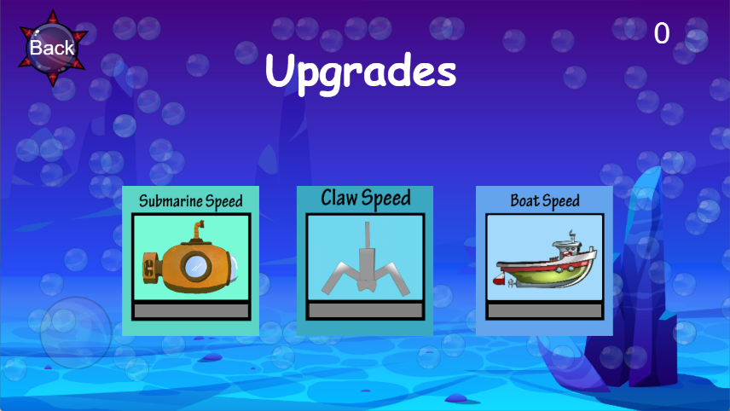

*Figure 42: MOD Screen*

## Settings Screen

The settings panel in "Trash Hunter: Submarine Edition" provides players with three main options for customizing their gaming experience. This includes:

**Sound Options:** Players can customize the sound settings by modifying the volume levels to create an immersive and fun gameplay experience. This guarantees that the game's audio features, such as ambient sounds and effects, are consistent with individual preferences.

**Music:** The option to alter music settings allows gamers to customize the tone of their gaming experience. Whether they prefer a lively soundtrack or a more relaxing atmosphere, the music selection provides a personalized and delightful aural experience.

**Login:** The login option improves the player experience by adding a personal touch. This feature allows players to access their profiles, track achievements, and participate in multiplayer portions of the game, which fosters a sense of continuity and community.

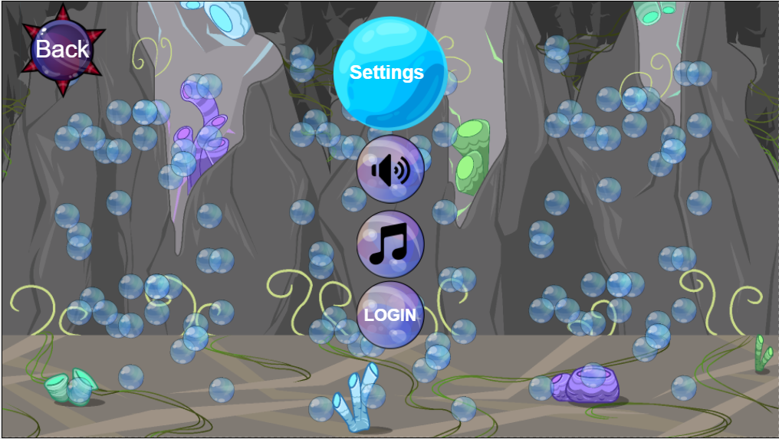

*Figure 43: Settings Screen*

## Select Level Screen

The Select Level screen in "Trash Hunter: Submarine Edition" has a visually appealing and intuitively built interface. With five separate levels, the inventive UI not only acts as a gateway to a variety of gaming experiences, but it also improves the overall visual attractiveness.

The carefully developed UI reflects the essence of each level, resulting in a visually distinct and entertaining environment. Each level has its own set of visuals and thematic components that give players a sense of the obstacles and locations they will face.

The Select Level panel not only simplifies navigation but also creates a sense of suspense as players choose their gaming path. The gorgeous and imaginative user interface not only helps players through level selection but also immerses them in the thematic richness that "Trash Hunter: Submarine Edition" has to offer, resulting in an expanded and visually spectacular gameplay experience.

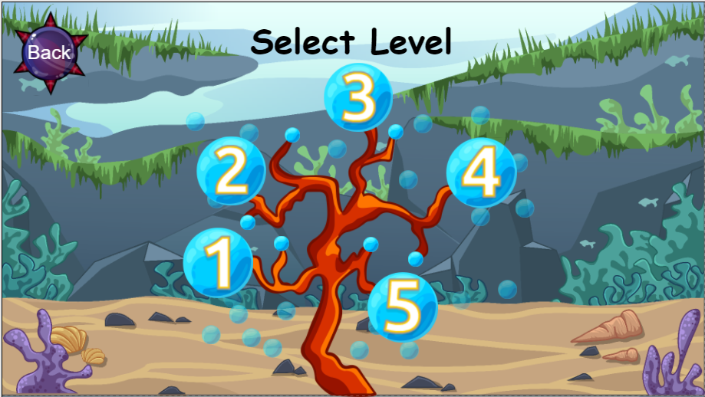

Figure 44: Select Level Screen

# MOBILE UI

Developing a seamless and intuitive mobile user interface (UI) for "Trash Hunter: Submarine Edition" improves the whole gaming experience, making it more accessible and interesting for users on mobile devices. Here are key considerations for the mobile UI:

## Responsive Design

Ensure that the UI elements are responsive to the various screen sizes and resolutions often found on mobile devices. This adaptability guarantees that the game remains visually appealing and usable across a variety of smartphones and tablets.

## Touch Friendly Controls

Create touch-friendly controls for easy navigation. The submarine movement, claw actions, and other interactions should be optimized for touchscreens to ensure a seamless and responsive experience.

### Buttons in the Mobile Version Game

* This button facilitates the lowering and boarding of the submarine onto the boat.

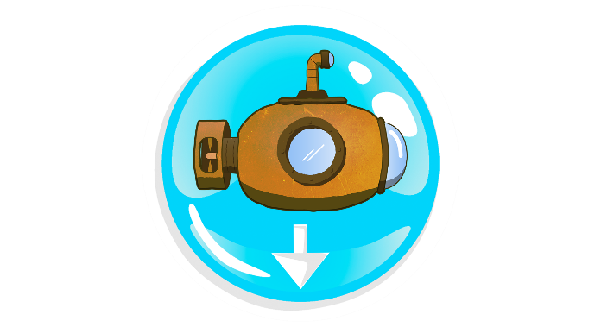

*Figure 45: Drop Submarine Button*

* This button facilitates the boarding of trash on the boat.

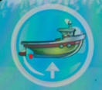

*Figure 46: Board Trash on Boat Button*

* This button facilitates collection of trash with the claw.



*Figure 47: Collect Trash Button*

## Game Mobile Interface

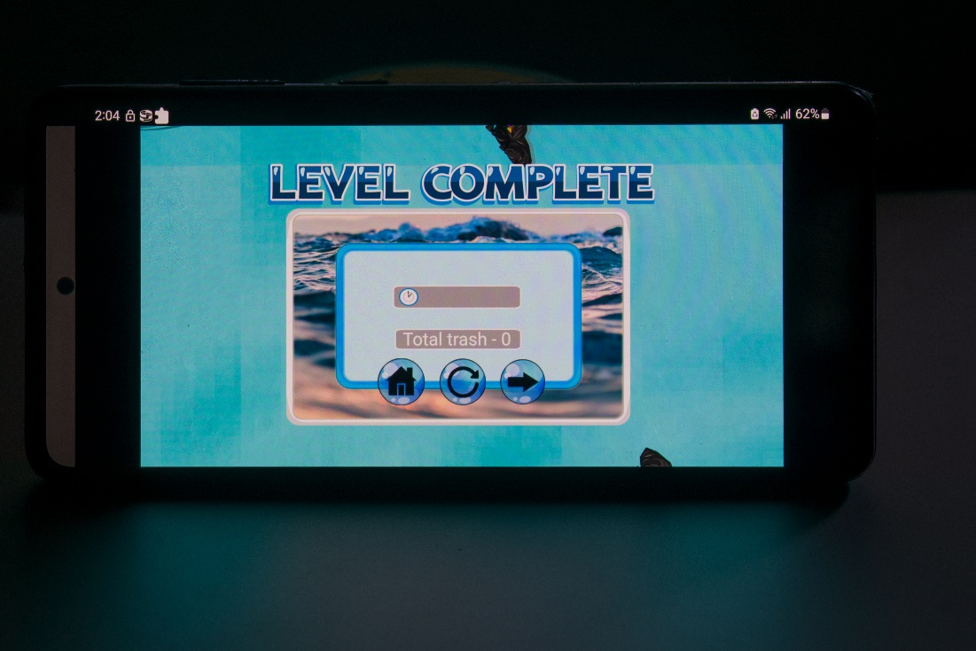

*Figure 48: Level Completed UI*

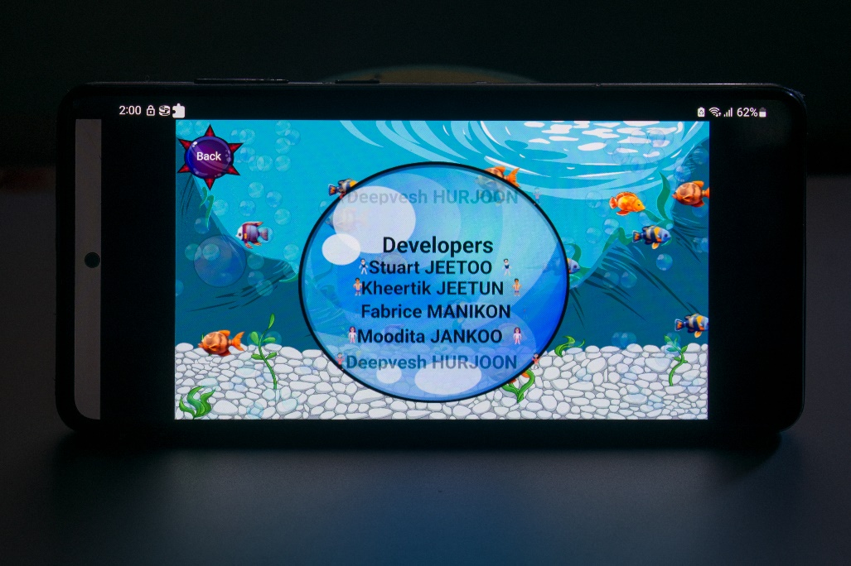

*Figure 49: Credit Screen UI*

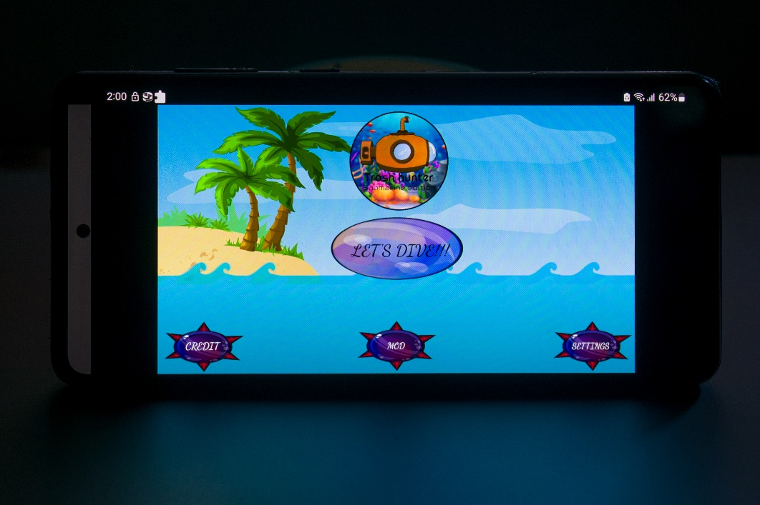

*Figure 50: Start Screen UI*

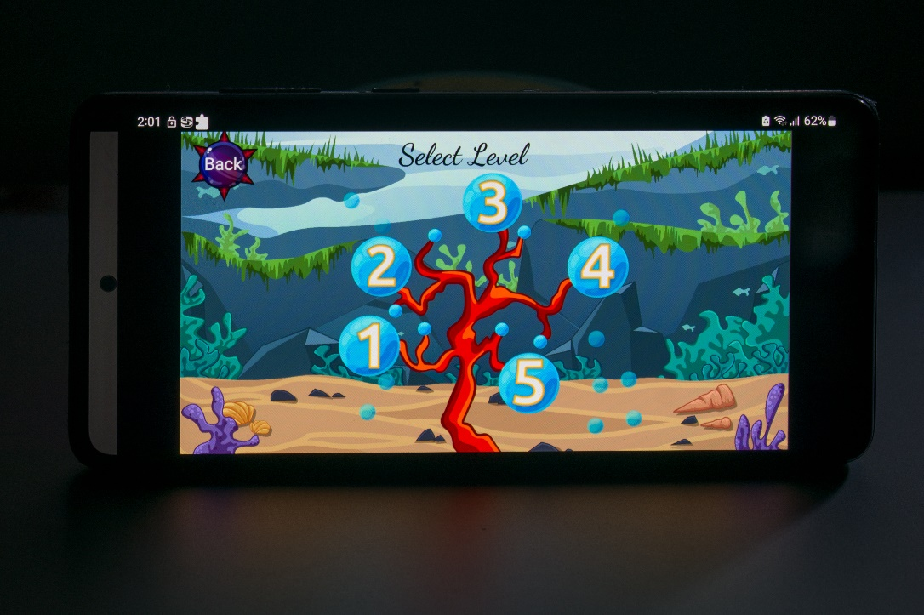

*Figure 51: Start Screen UI*

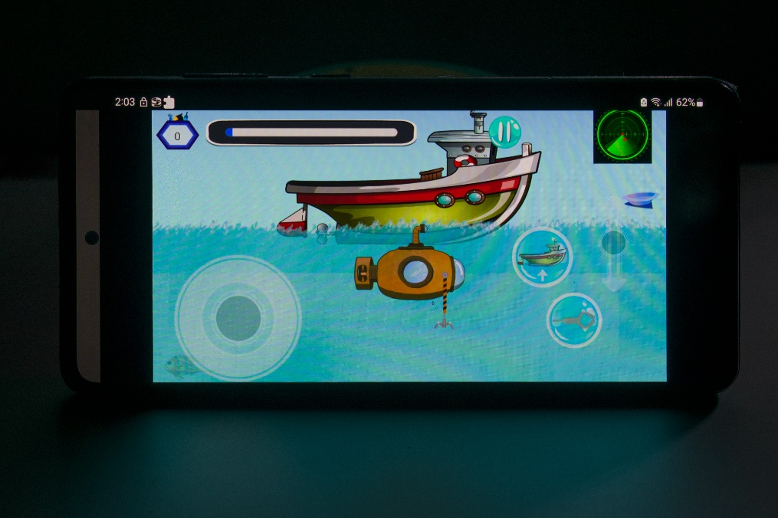

*Figure 52: Level UI*

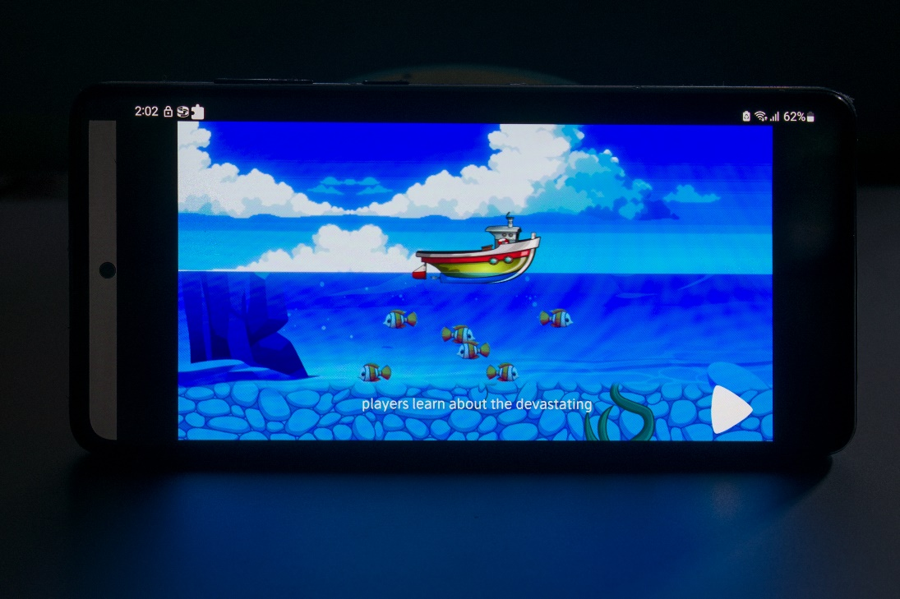

*Figure 53: Story Screen UI*

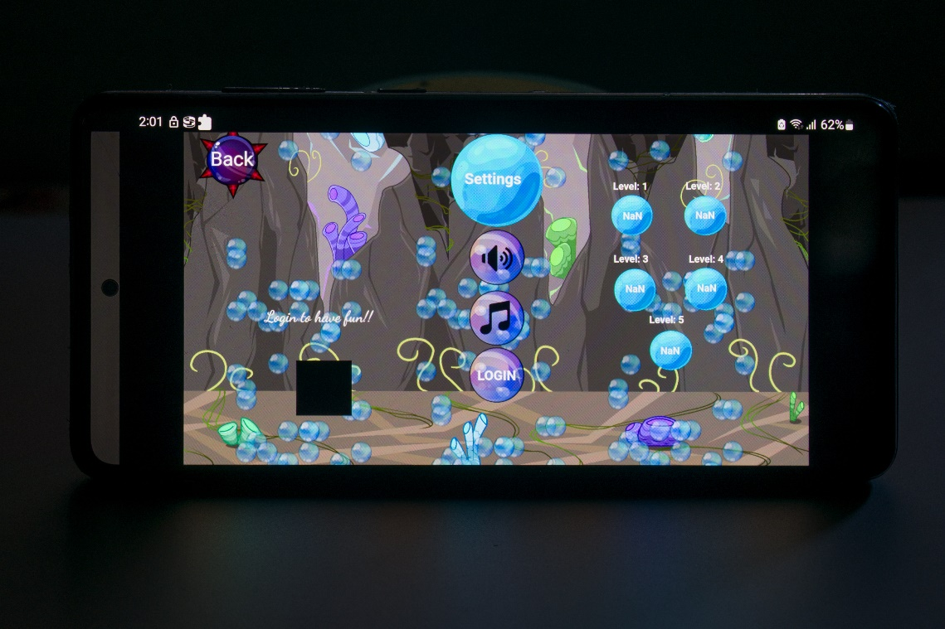

*Figure 54: Setting Screen UI*

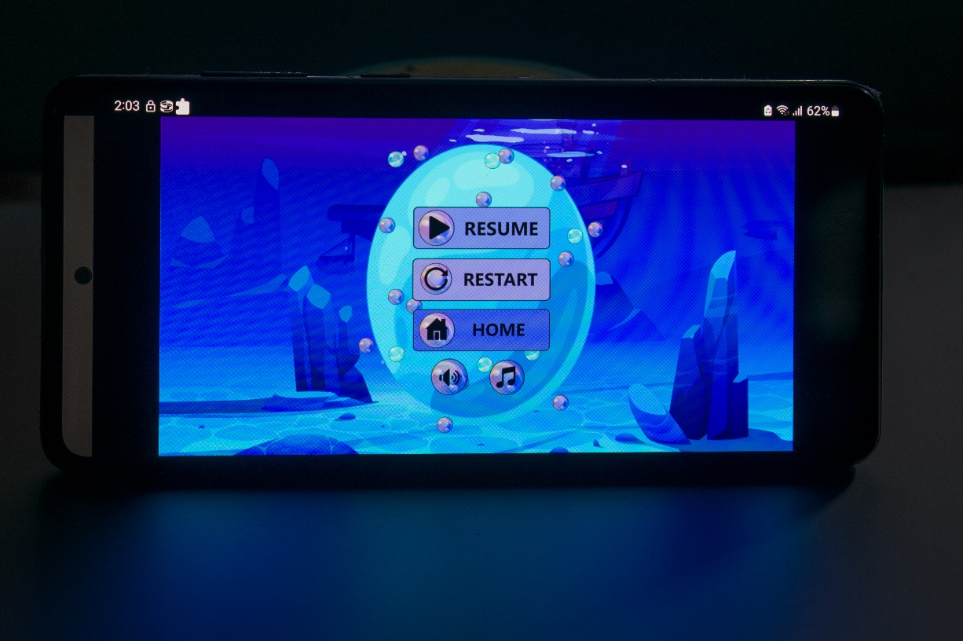

*Figure 55: Pause Screen UI*